

Cloud Computing Lab 14

Submitted To: Sir Waqas Saleem & Sie Shoaib
Submitted By: Hamail Fatima
Roll No: 2023-BSE-023
Section: 5(A)

Course Name: Cloud Computing

Lab 14 repo link: https://github.com/Hamail-maker/terraform_machine

Lab # 14

Task 0 – Lab Setup (Codespace & GH CLI)
- Fork the repo terraform_machine
- Create/open Codespace on your GitHub account (from terraform_machine repo).
  - Save screenshot as: task0_codespace_open.png — browser showing the Codespace opened.

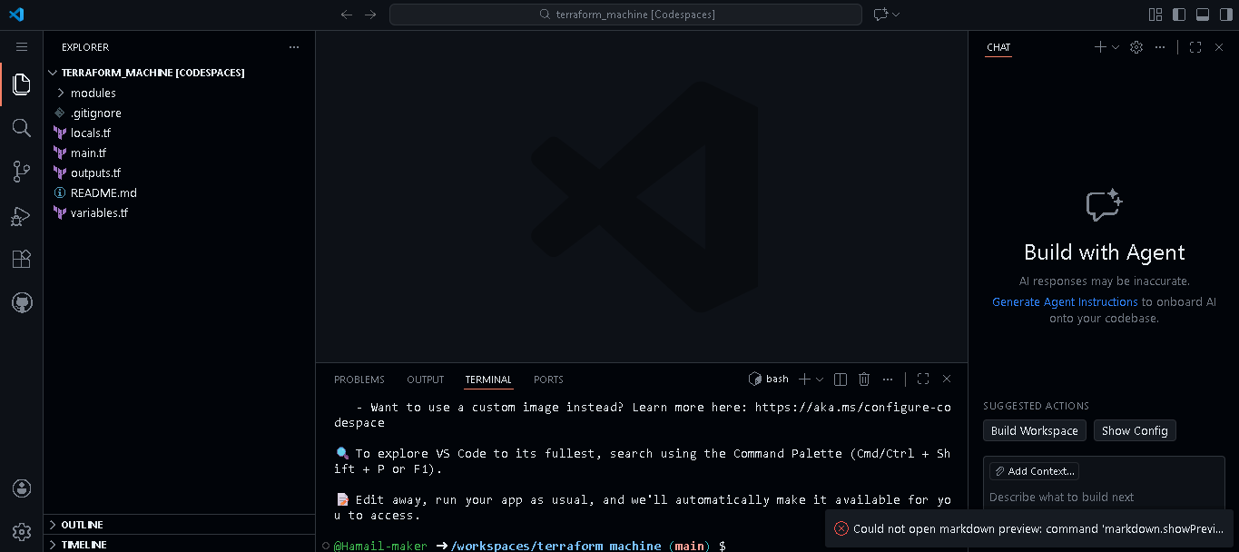

- Inside the Codespace terminal, verify:
aws --version
terraform --version
ansible --version || echo "ansible not yet installed"
- Save screenshot as: task0_env_check.png — Codespace terminal showing aws --version, terraform -version, and ansible --version or the “not installed yet” message.

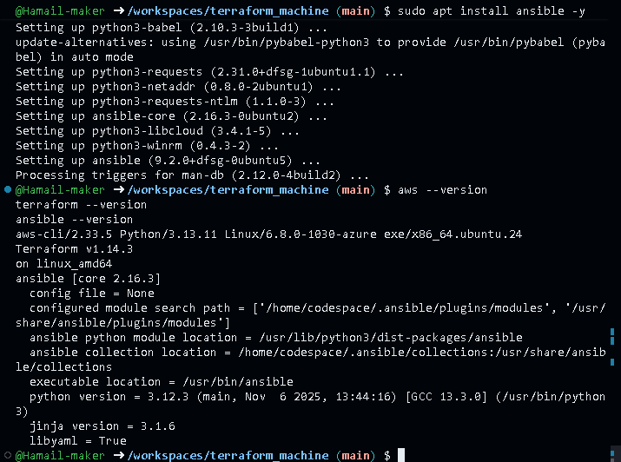

- Ensure AWS CLI is configured with credentials that have permissions to create EC2, VPC, subnets, and security groups in region me-central-1:
aws sts get-caller-identity
- Save screenshot as: task0_aws_config.png — output of aws sts get-caller-identity.

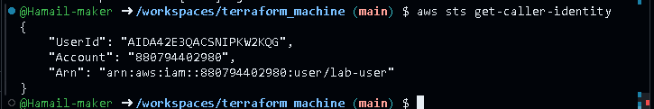

Task 1 – Generate ssh key and Initial Terraform apply
You will start from an existing repository and prepare Terraform variables and SSH keys.
- Check SSH directory & generate SSH key pair if not already present:
ls ~/.ssh
ssh-keygen -t ed25519 -f ~/.ssh/id_ed25519 -N ""
ls -la ~/.ssh
- Save screenshot as: task1_ssh_keygen_before.png — ls ~/.ssh before key generation.

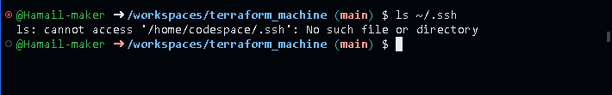

- Save screenshot as: task1_ssh_keygen.png — output of ssh-keygen command.

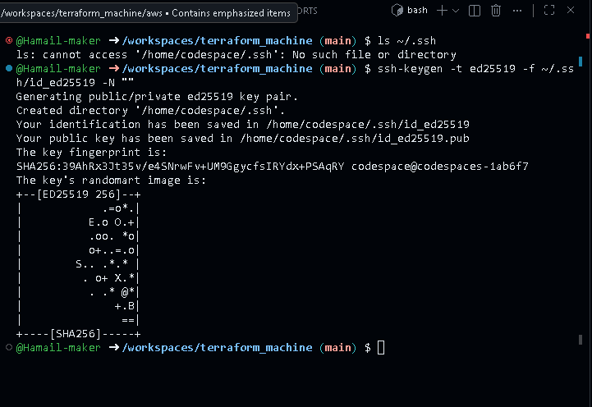

- Save screenshot as: task1_ssh_keygen_after.png — ls -la ~/.ssh showing id_ed25519 and id_ed25519.pub.

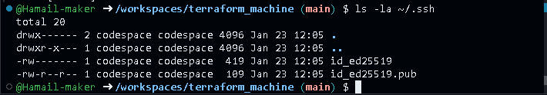

- Create terraform.tfvars in the repo root:
cd /workspaces/terraform_machine
touch terraform.tfvars
ls -la terraform.tfvars
- Save screenshot as: task1_terraform_tfvars_created.png — touch terraform.tfvars and ls -la terraform.tfvars.



Add the following content:
vpc_cidr_block = "10.0.0.0/16"
subnet_cidr_block = "10.0.10.0/24"
availability_zone = "me-central-1a"
env_prefix = "dev"
instance_type = "t3.micro"
public_key = "~/.ssh/id_ed25519.pub"
private_key = "~/.ssh/id_ed25519"
- Save screenshot as: task1_terraform_tfvars.png — content of terraform.tfvars.

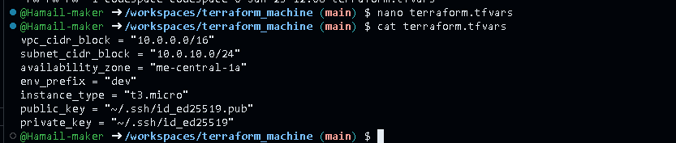

- Initialize Terraform:
terraform init
- Save screenshot as: task1_terraform_init.png — terraform init output.

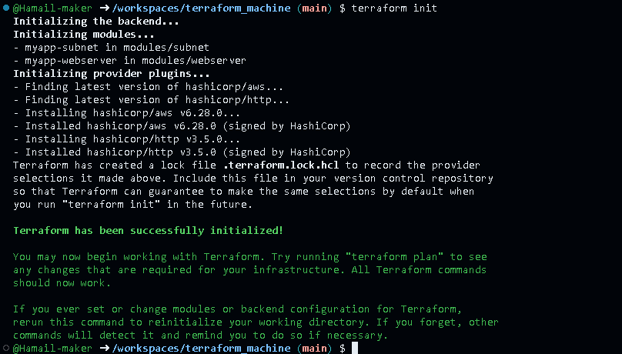

- Apply Terraform to create 2 EC2 instances (as defined in the existing Terraform code):
terraform apply -auto-approve
- Save screenshot as: task1_terraform_apply_2_instances.png — terraform apply output showing 2 instances created.

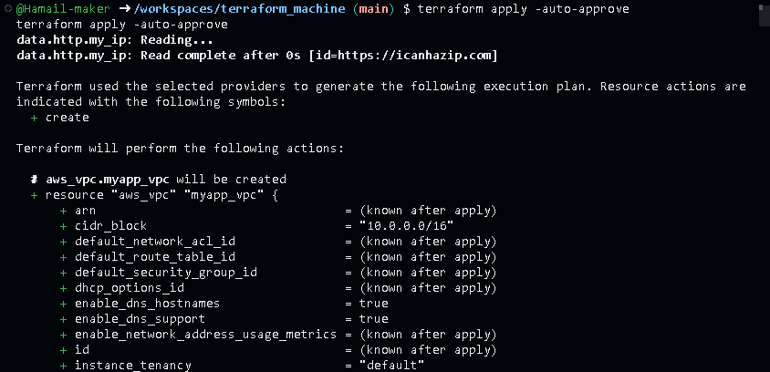

- Check outputs:
terraform output
- Save screenshot as: task1_terraform_output_ips.png — terraform output showing instance IPs.

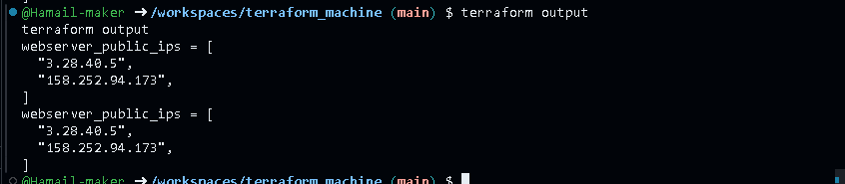

Task 2 – Static Ansible inventory with two EC2 instances
You will install Ansible (via pipx), create a static inventory, and verify connectivity.
- Install Ansible (core) using pipx:
pipx install ansible-core
ansible --version
- Save screenshot as: task2_ansible_install.png — pipx install ansible-core and ansible --version output.

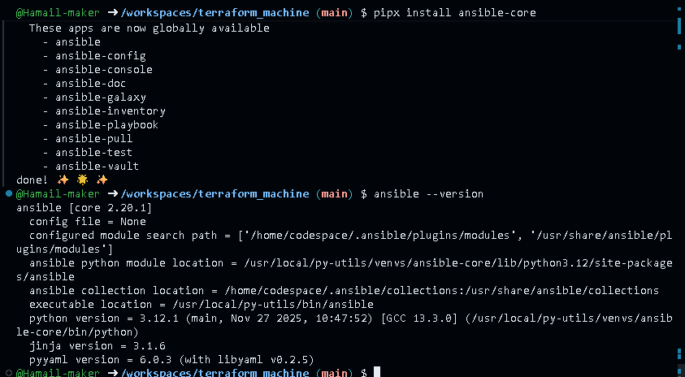

- Obtain the two public IPs of your EC2 instances:
terraform output
- Save screenshot as: task2_terraform_output_ips.png — terraform output listing at least 2 EC2 public IPs.

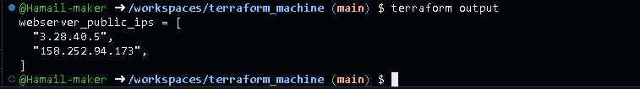

- Create Ansible inventory file hosts:
touch hosts
ls -la hosts

- Save screenshot as: task2_hosts_created.png — confirmation that hosts file exists.

Add the following (replace <public-ip-ec2> with your 2 real IPs):
<public-ip-ec2> ansible_user=ec2-user ansible_ssh_private_key_file=~/.ssh/id_ed25519
<public-ip-ec2> ansible_user=ec2-user ansible_ssh_private_key_file=~/.ssh/id_ed25519
- Save screenshot as: task2_hosts_initial.png — content of hosts with two IP lines.

- Test connectivity:
ansible all -i hosts -m ping
- Save screenshot as: task2_ansible_ping_initial.png — initial ansible all -i hosts -m ping output (success or failure).

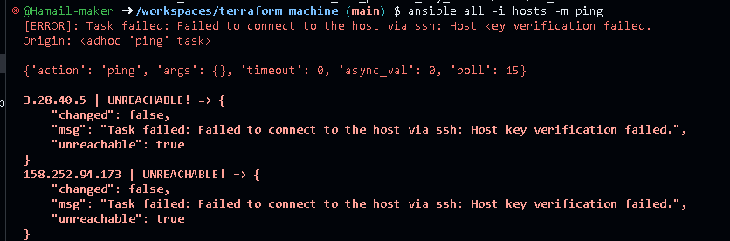

- If it fails due to host key checking, add this to each line in hosts:
ansible_ssh_common_args='-o StrictHostKeyChecking=no'
- Save screenshot as: task2_hosts_with_common_args.png — hosts content with ansible_ssh_common_args added.

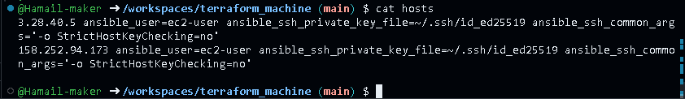

- Retry:
ansible all -i hosts -m ping
- Save screenshot as: task2_ansible_ping_success.png — successful ping output.

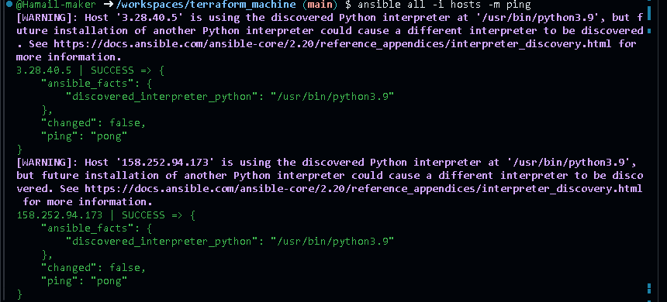

Task 3 - Scale to three instances & group-based inventory
You will expand to 3 web servers via Terraform’s count and restructure your inventory into groups.
- Update your Terraform module for webservers in main.tf to use count = 3:
module "myapp-webserver" {
source = "./modules/webserver"
env_prefix = var.env_prefix
instance_type = var.instance_type
availability_zone = var.availability_zone
public_key = var.public_key
my_ip = local.my_ip
vpc_id = aws_vpc.myapp_vpc.id
subnet_id = module.myapp-subnet.subnet.id

# Loop count
count = 3
# Use count.index to differentiate instances
instance_suffix = count.index
}
- Save screenshot as: task3_main_tf_count_3.png — main.tf snippet showing count = 3.

- Apply Terraform to get 3 instances:
terraform apply -auto-approve
- Save screenshot as: task3_terraform_apply_3_instances.png — terraform apply output creating 3 instances.

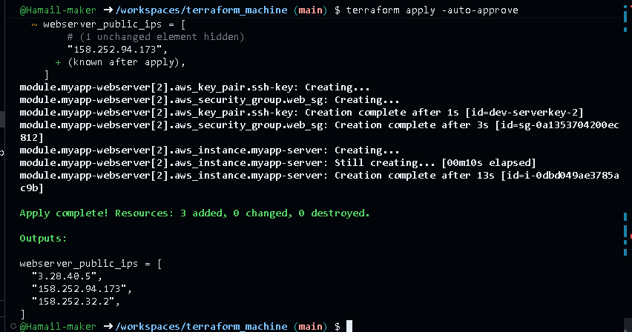

- Check outputs:
terraform output
- Save screenshot as: task3_terraform_output_3_ips.png — terraform output listing 3 public IPs.

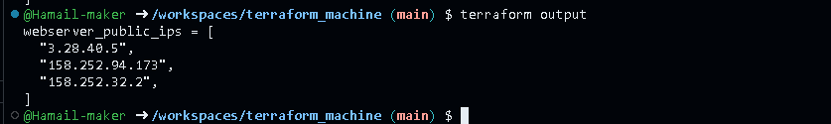

- Rewrite your hosts file using group definitions:
[ec2]
<public-ip-ec2>
<public-ip-ec2>

[ec2:vars]
ansible_user=ec2-user
ansible_ssh_private_key_file=~/.ssh/id_ed25519
ansible_ssh_common_args='-o StrictHostKeyChecking=no'

[droplet]
<public-ip-third-ec2>

[droplet:vars]
ansible_user=ec2-user
ansible_ssh_private_key_file=~/.ssh/id_ed25519
ansible_ssh_common_args='-o StrictHostKeyChecking=no'
- Save screenshot as: task3_hosts_grouped.png — hosts showing [ec2] and [droplet] with three IPs.

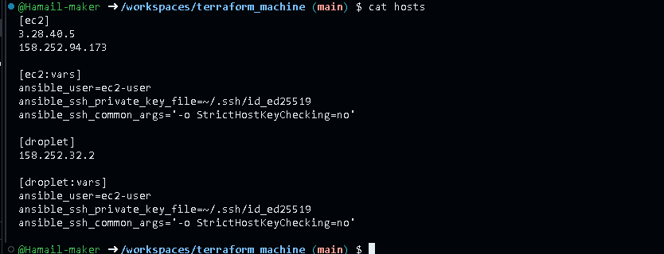

- Test group connectivity:
ansible ec2 -i hosts -m ping
- Save screenshot as: task3_ansible_ec2_ping.png — output of ansible ec2 -i hosts -m ping.

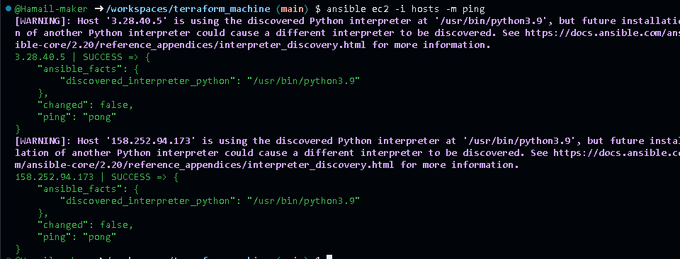

- Test single host by IP:
ansible <one-public-ip-from-ec2-group> -i hosts -m ping
- Save screenshot as: task3_ansible_single_ip_ping.png — ping output for one EC2 IP.

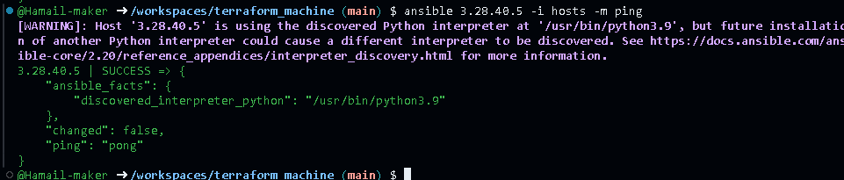

- Test droplet group:
ansible droplet -i hosts -m ping
- Save screenshot as: task3_ansible_droplet_ping.png — ping output for droplet group.

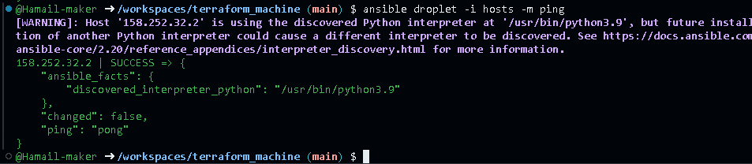

- Test all hosts:
ansible all -i hosts -m ping
- Save screenshot as: task3_ansible_all_ping.png — ping output for all instances.

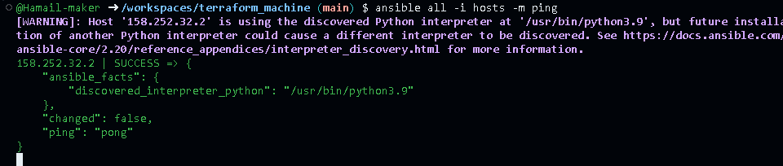

Task 4 – Global ansible.cfg & first nginx playbook
You will configure a global Ansible configuration file, then create a basic playbook for nginx.
- Create global Ansible configuration:
vim ~/.ansible.cfg
Add:
[default]
host_key_checking = False
interpreter_python = /usr/bin/python3
- Save screenshot as: task4_global_ansible_cfg.png — content of ~/.ansible.cfg.

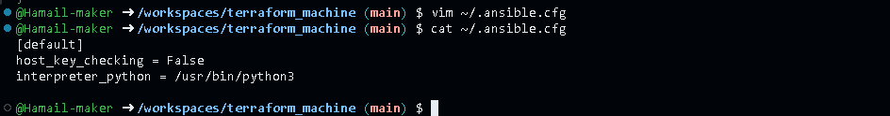

- Remove ansible_ssh_common_args from hosts (delete from all groups).
  - Save screenshot as: task4_hosts_without_common_args.png — hosts after removal.

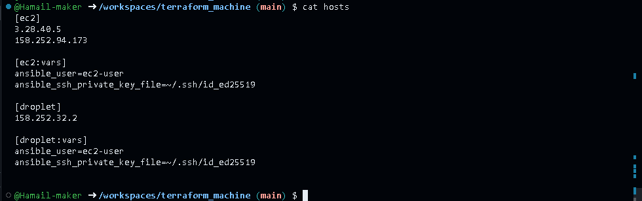

- Confirm connectivity:
ansible all -i hosts -m ping
- Save screenshot as: task4_ansible_ping_after_cfg.png — ping output showing success, no strict host checking warning.

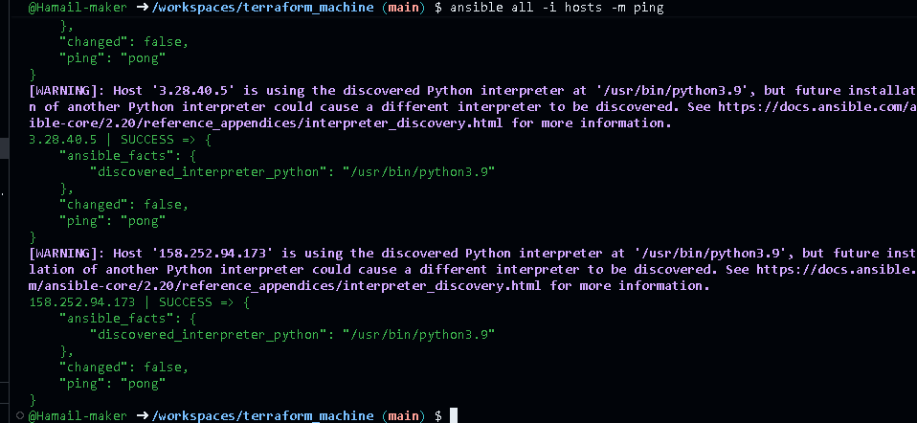

- Create my-playbook.yaml:
touch my-playbook.yaml
ls -la my-playbook.yaml
- Save screenshot as: task4_my_playbook_created.png — existence of my-playbook.yaml.

Add:
---
- name: Configure nginx web server
hosts: ec2
become: true
tasks:
- name: install nginx and update cache
yum:
name: nginx
state: present
update_cache: yes

- name: start nginx server
service:
name: nginx
state: started
- Save screenshot as: task4_my_playbook_ec2.png — content of my-playbook.yaml with hosts: ec2.

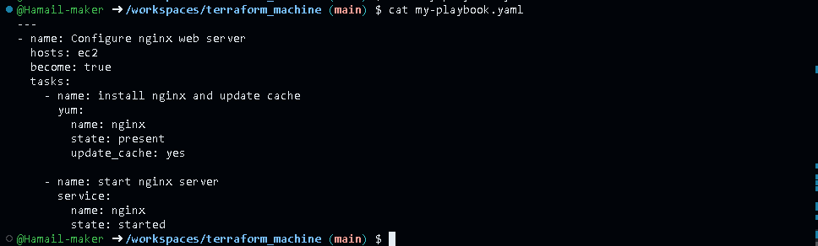

- Run the playbook on [ec2] group:
ansible-playbook -i hosts my-playbook.yaml
- Save screenshot as: task4_ansible_play_ec2.png — playbook output for ec2 group.

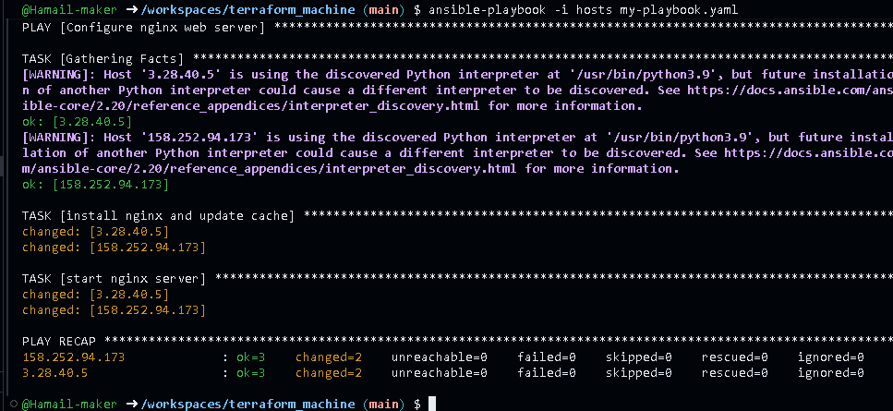

- Verify nginx default page on [ec2] servers by visiting http://<public-ip-ec2>.
  - Save screenshot as: task4_nginx_browser_ec2.png — browser showing nginx default page for an ec2 instance.

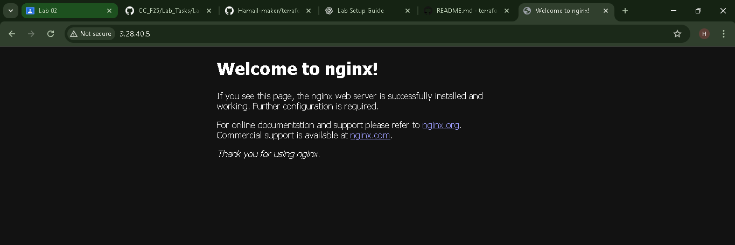

- Change target to droplet:
Edit my-playbook.yaml to:
hosts: droplet

- Save screenshot as: task4_my_playbook_droplet.png — playbook with hosts: droplet.

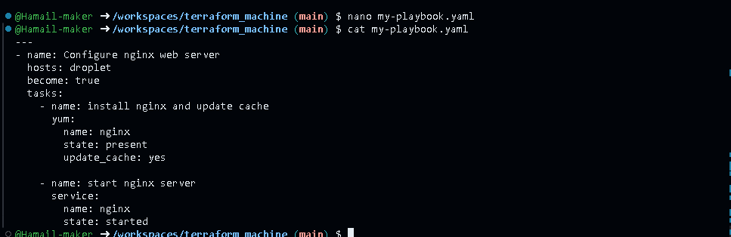

- Re-run:
ansible-playbook -i hosts my-playbook.yaml
- Save screenshot as: task4_ansible_play_droplet.png — output of playbook for droplet group.

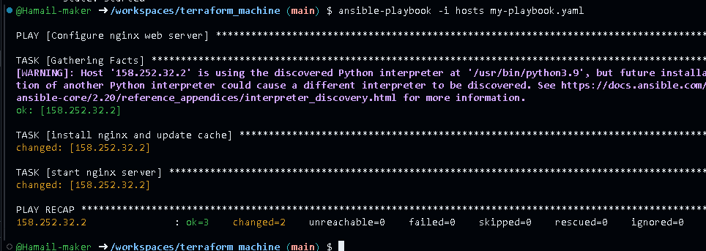

- Verify nginx default page on droplet:
  - Save screenshot as: task4_nginx_browser_droplet.png — browser showing nginx page on droplet.

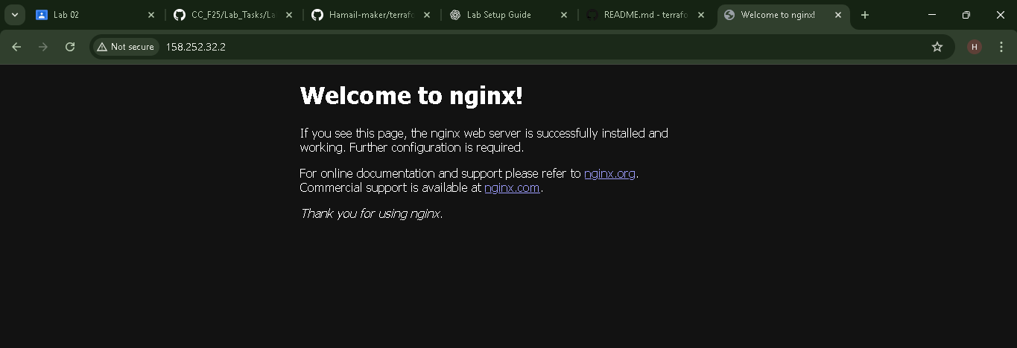

Task 5 – Single nginx target group & HTTPS prerequisites
You will prepare project-level Ansible configuration and adjust nginx installation scope.
- Create project-level ansible.cfg in repo root:
touch ansible.cfg
ls -la ansible.cfg
- Save screenshot as: task5_project_ansible_cfg_created.png — project ansible.cfg presence.



Add:
[defaults]
host_key_checking=False
interpreter_python = /usr/bin/python3
- Save screenshot as: task5_project_ansible_cfg.png — project-level ansible.cfg content.



- Switch Terraform EC2 count back to 1:
In main.tf:
count = 1
- Save screenshot as: task5_main_tf_count_1.png — snippet showing count = 1.

- Apply:
terraform apply -auto-approve
- Save screenshot as: task5_terraform_apply_one_instance.png — apply output with one instance.

- Outputs:
terraform output
- Save screenshot as: task5_terraform_output_single_ip.png — single EC2 public IP.

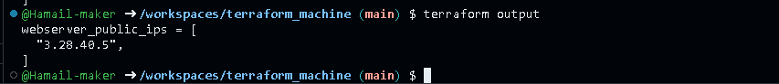

- Adjust hosts:
[nginx]
<single-public-ip>

[nginx:vars]
ansible_ssh_private_key_file=~/.ssh/id_ed25519
ansible_user=ec2-user
- Save screenshot as: task5_hosts_nginx_group.png — hosts file for [nginx].

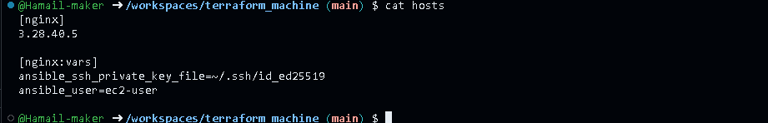

- Update my-playbook.yaml:
---
- name: Configure nginx web server
hosts: nginx
become: true
tasks:
- name: install nginx and update cache
yum:
name: nginx
state: present
update_cache: yes

- name: install openssl
yum:
name: openssl
state: present

- name: start nginx server
service:
name: nginx
state: started
enabled: true
- Save screenshot as: task5_my_playbook_nginx_group.png — playbook with hosts: nginx.

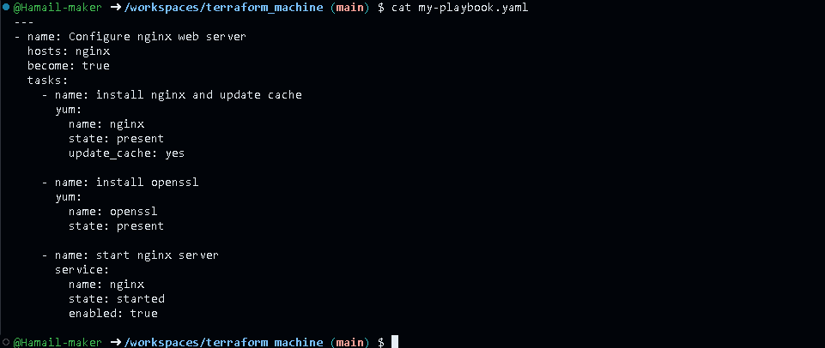

- Run the playbook:
ansible-playbook -i hosts my-playbook.yaml

- Save screenshot as: task5_ansible_play_nginx_group.png — playbook output.

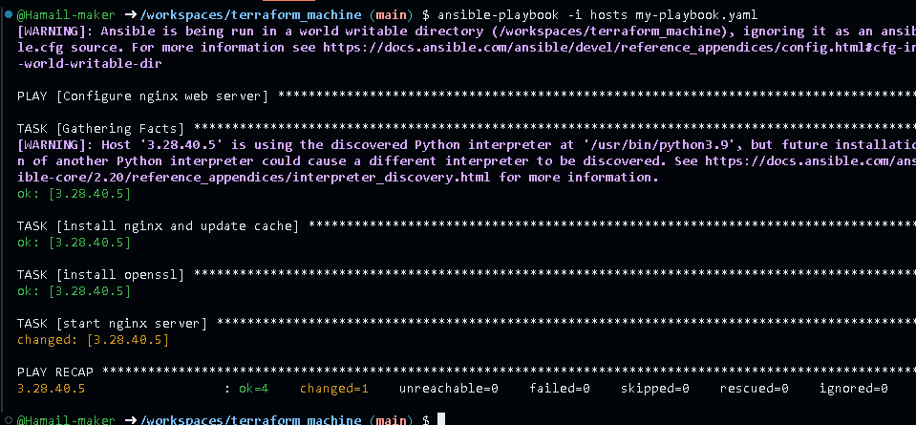

- Verify nginx default page at http://<public-ip>.
  - Save screenshot as: task5_nginx_browser_single.png — browser view.

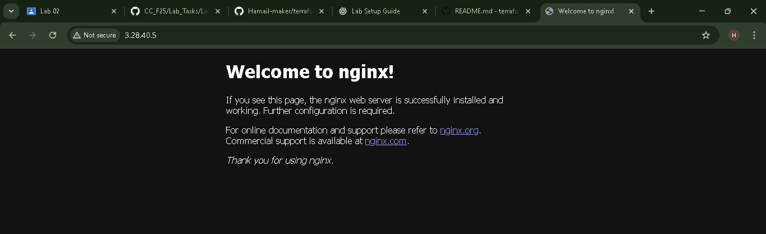

Task 6 - Ansible-managed SSL certificates
Extend your playbook to generate self-signed SSL certificates using dynamic public IP.
- Append this play after the nginx play in my-playbook.yaml:
- name: Configure SSL certificates
hosts: nginx
become: true
tasks:
- name: Create SSL private directory
file:
path: /etc/ssl/private
state: directory
mode: '0700'

- name: Create SSL certs directory
file:
path: /etc/ssl/certs
state: directory
mode: '0755'

- name: Get IMDSv2 token
uri:
url: "http://169.254.169.254/latest/api/token"
method: PUT
headers:
X-aws-ec2-metadata-token-ttl-seconds: "3600"
return_content: yes
register: imdsv2_token

- name: Get current public IP
uri:
url: "http://169.254.169.254/latest/meta-data/public-ipv4"
headers:
X-aws-ec2-metadata-token: "{{ imdsv2_token.content }}"
return_content: yes
register: public_ip

- name: Show current public IP
debug:
msg: "Public IP: {{ public_ip.content }}"

- name: Generate self-signed SSL certificate
command: >
openssl req -x509 -nodes -days 365
-newkey rsa:2048
-keyout /etc/ssl/private/selfsigned.key
-out /etc/ssl/certs/selfsigned.crt
-subj "/CN={{ public_ip.content }}"
-addext "subjectAltName=IP:{{ public_ip.content }}"
-addext "basicConstraints=CA:FALSE"
-addext "keyUsage=digitalSignature,keyEncipherment"
-addext "extendedKeyUsage=serverAuth"
args:
creates: /etc/ssl/certs/selfsigned.crt
- Save screenshot as: task6_my_playbook_ssl_section.png — SSL block in my-playbook.yaml.

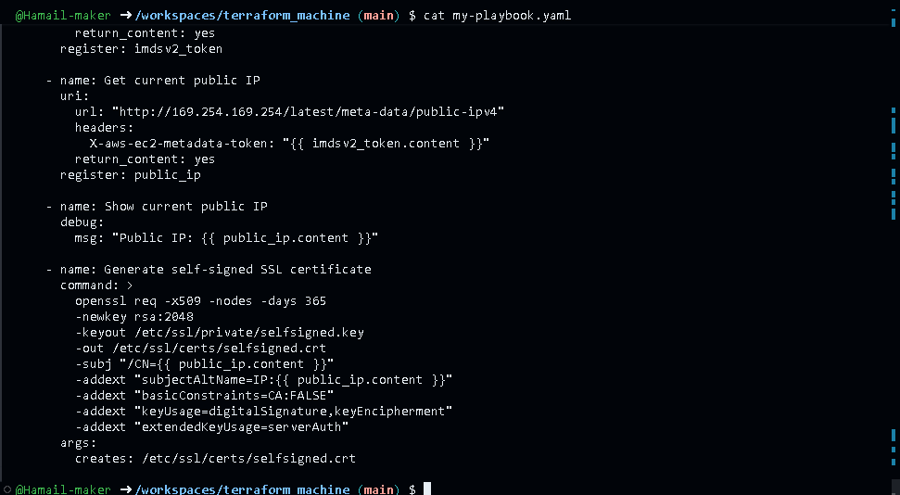

- Run:
ansible-playbook -i hosts my-playbook.yaml
- Save screenshot as: task6_ansible_play_ssl.png — SSL tasks output.

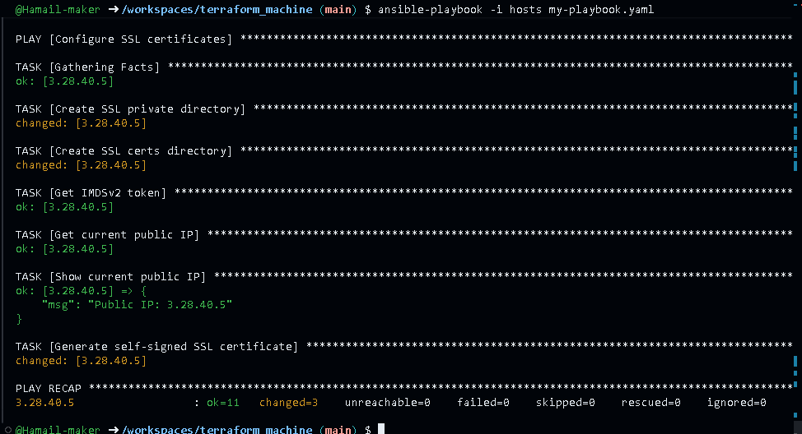

- SSH and verify:
ssh ec2-user@<public-ip> -i ~/.ssh/id_ed25519
sudo cat /etc/ssl/certs/selfsigned.crt
sudo cat /etc/ssl/private/selfsigned.key
exit
- Save screenshot as: task6_ssl_cert_file.png — cat /etc/ssl/certs/selfsigned.crt.

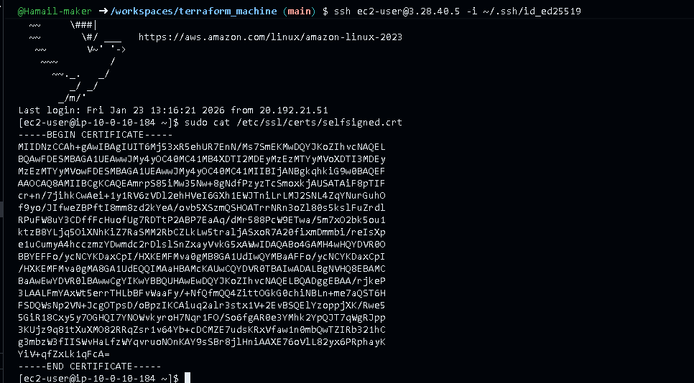

- Save screenshot as: task6_ssl_key_file.png — cat /etc/ssl/private/selfsigned.key.

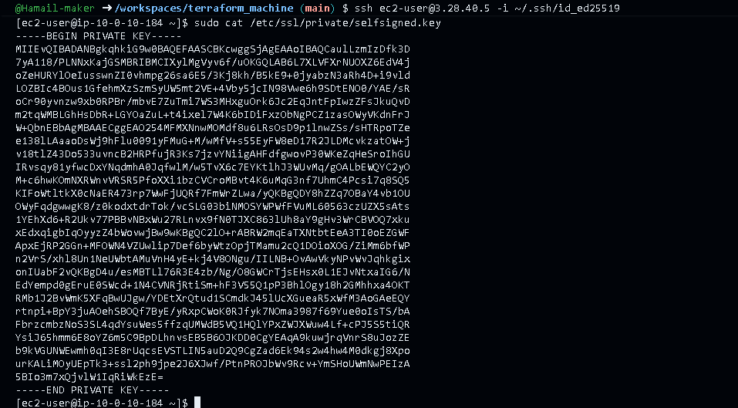

Task 7 - PHP front-end deployment with templates
Deploy a PHP application and Nginx configuration using Ansible copy and template.
- Create directories and files:
mkdir -p files templates
touch files/index.php
touch templates/nginx.conf.j2
ls -R
- Save screenshot as: task7_files_templates_created.png — ls -R showing files/index.php and templates/nginx.conf.j2.

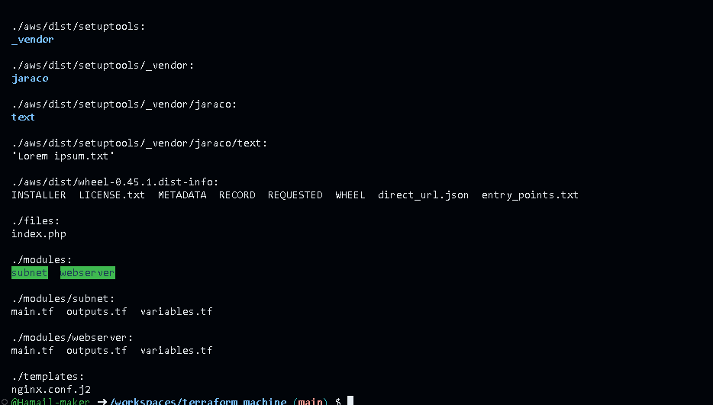

- Fill files/index.php with the following PHP metadata page:
<?php
// Get hostname
$hostname = gethostname();

// Deployment date
$deployed_date = date("Y-m-d H:i:s");

// Metadata base URL
$metadata_base = "http://169.254.169.254/latest/";

// Function to get IMDSv2 token
function getImdsV2Token() {
$ch = curl_init("http://169.254.169.254/latest/api/token");
curl_setopt_array($ch, [
CURLOPT_RETURNTRANSFER => true,
CURLOPT_CUSTOMREQUEST => "PUT",
CURLOPT_HTTPHEADER => [
"X-aws-ec2-metadata-token-ttl-seconds: 21600"
],
CURLOPT_TIMEOUT => 2
]);

$token = curl_exec($ch);
curl_close($ch);

return $token ?: null;
}

// Function to fetch metadata using token
function getMetadata($path, $token) {
$url = "http://169.254.169.254/latest/meta-data/" . $path;

$ch = curl_init($url);
curl_setopt_array($ch, [
CURLOPT_RETURNTRANSFER => true,
CURLOPT_HTTPHEADER => [
"X-aws-ec2-metadata-token: $token"
],
CURLOPT_TIMEOUT => 2
]);

$value = curl_exec($ch);
curl_close($ch);

return $value ?: "N/A";
}

// Fetch token
$token = getImdsV2Token();

// Fetch metadata only if token is available
$instance_id = $token ? getMetadata("instance-id", $token) : "N/A";
$private_ip = $token ? getMetadata("local-ipv4", $token) : "N/A";
$public_ip = $token ? getMetadata("public-ipv4", $token) : "N/A";
$public_dns = $token ? getMetadata("public-hostname", $token) : "N/A";
?>
<!DOCTYPE html>
<html>
<head>
<title>Frontend Web Server</title>
<style>
body {
font-family: Arial, sans-serif;
margin: 50px;
background: linear-gradient(135deg, #667eea 0%, #764ba2 100%);
color: white;
}
.container {
background: rgba(255, 255, 255, 0.1);
padding: 30px;
border-radius: 10px;
box-shadow: 0 8px 32px rgba(31, 38, 135, 0.37);
}
h1 {
color: #fff;
text-shadow: 2px 2px 4px rgba(0,0,0,0.3);
}
.info {
margin: 15px 0;
padding: 10px;
background: rgba(255,255,255,0.2);
border-radius: 5px;
}
.label {
font-weight: bold;
color: #ffd700;
}
.info a {
color: white; /* same as other values */
text-decoration: none; /* remove underline */
font-weight: normal;
}

.info a:hover {
text-decoration: underline; /* optional: underline on hover */
}
</style>
</head>
<body>
<div class="container">
<h1>🚀 Nginx Front End Web Server </h1>

<div class="info"><span class="label">Hostname:</span> <?= htmlspecialchars($hostname) ?></div>
<div class="info"><span class="label">Instance ID:</span> <?= htmlspecialchars($instance_id) ?></div>
<div class="info"><span class="label">Private IP:</span> <?= htmlspecialchars($private_ip) ?></div>
<div class="info"><span class="label">Public IP:</span> <?= htmlspecialchars($public_ip) ?></div>
<div class="info"><span class="label">Public DNS:</span>
<a href="https://<?= htmlspecialchars($public_dns) ?>" target="_blank">
https://<?= htmlspecialchars($public_dns) ?></a>
</div>
<div class="info"><span class="label">Deployed:</span> <?= $deployed_date ?></div>
<div class="info"><span class="label">Status:</span> ✅ Active and Running</div>
<div class="info"><span class="label">Managed By:</span> Terraform + Ansible</div>
</div>
</body>
</html>
- Save screenshot as: task7_index_php_content.png — content of files/index.php in editor or cat.

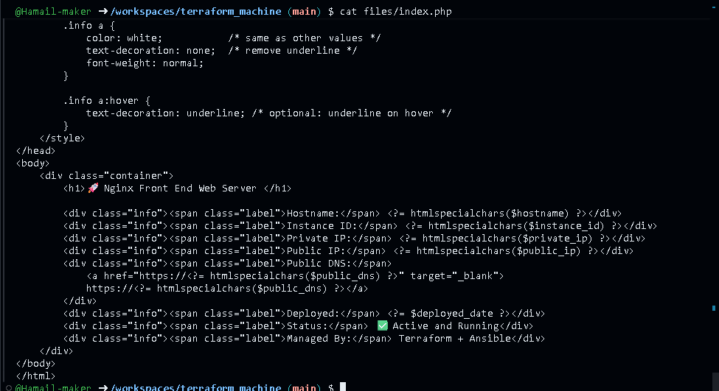

- Fill templates/nginx.conf.j2 with the following Nginx configuration template:
user nginx;
worker_processes auto;
error_log /var/log/nginx/error.log notice;
pid /run/nginx.pid;

events {
worker_connections 1024;
}

http {
log_format main '$remote_addr - $remote_user [$time_local] "$request"'
'$status $body_bytes_sent "$http_referer"'
'"$http_user_agent" "$http_x_forwarded_for"';

access_log /var/log/nginx/access.log main;

sendfile on;
tcp_nopush on;
keepalive_timeout 65;
types_hash_max_size 4096;

include /etc/nginx/mime.types;
default_type application/octet-stream;

upstream backend_servers {
server 158.252.94.241:80;
server 158.252.94.242:80 backup;
}

server {
listen 443 ssl;
server_name {{ server_public_ip }};
ssl_certificate /etc/ssl/certs/selfsigned.crt;
ssl_certificate_key /etc/ssl/private/selfsigned.key;

location / {
root /usr/share/nginx/html;
index index.php index.html index.htm;
# proxy_pass http://158.252.94.241:80;
# proxy_pass http://backend_servers;

# 🔴 This block is necessary for Php Website
location ~ \.php$ {
include fastcgi_params;
fastcgi_pass unix:/run/php-fpm/www.sock;
fastcgi_index index.php;
fastcgi_param SCRIPT_FILENAME $document_root$fastcgi_script_name;
}
}
}

server {
listen 80;
server_name _;
return 301 https://$host$request_uri;
}
}
- Save screenshot as: task7_nginx_conf_template.png — content of templates/nginx.conf.j2.

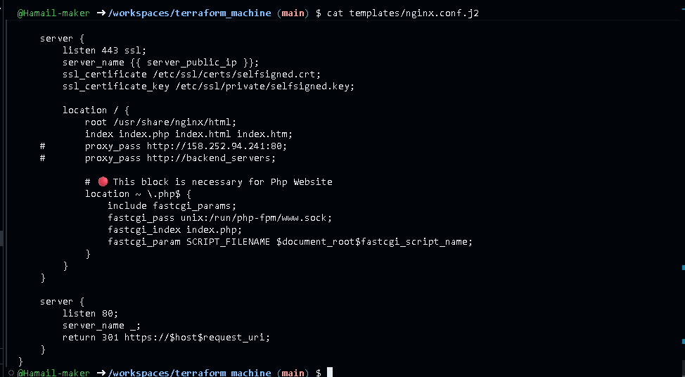

- Add this play to my-playbook.yaml:
- name: Deploy Nginx website and configuration files
hosts: nginx
become: true
tasks:
- name: install php-fpm and php-curl
yum:
name:
- php-fpm
- php-curl
state: present

- name: Copy website files
copy:
src: files/index.php
dest: /usr/share/nginx/html/index.php
owner: nginx
group: nginx
mode: '0644'

- name: Copy nginx.conf template
template:
src: templates/nginx.conf.j2
dest: /etc/nginx/nginx.conf
owner: root
group: root
mode: '0644'

- name: Restart nginx
service:
name: nginx
state: restarted

- name: Start and enable php-fpm
service:
name: php-fpm
state: started
enabled: true
- Save screenshot as: task7_my_playbook_web_deploy.png — updated my-playbook.yaml including this play.

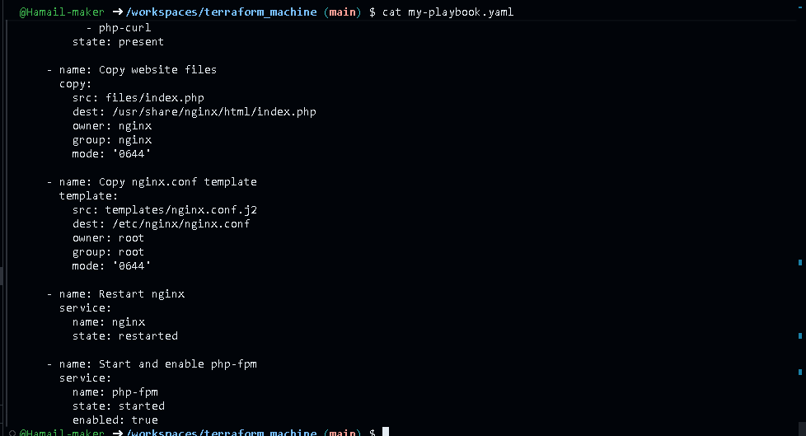

- Run the playbook:
ansible-playbook -i hosts my-playbook.yaml
- Save screenshot as: task7_ansible_play_web_deploy.png — playbook output showing PHP/nginx tasks executed.

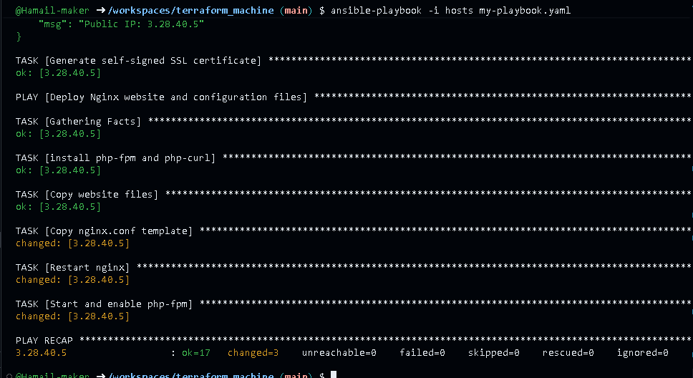

- Visit https://<public-ip>:
  - Accept SSL warning.
  - Verify the PHP page content.
- Save screenshot as: task7_php_https_browser.png — browser showing PHP web page via HTTPS.

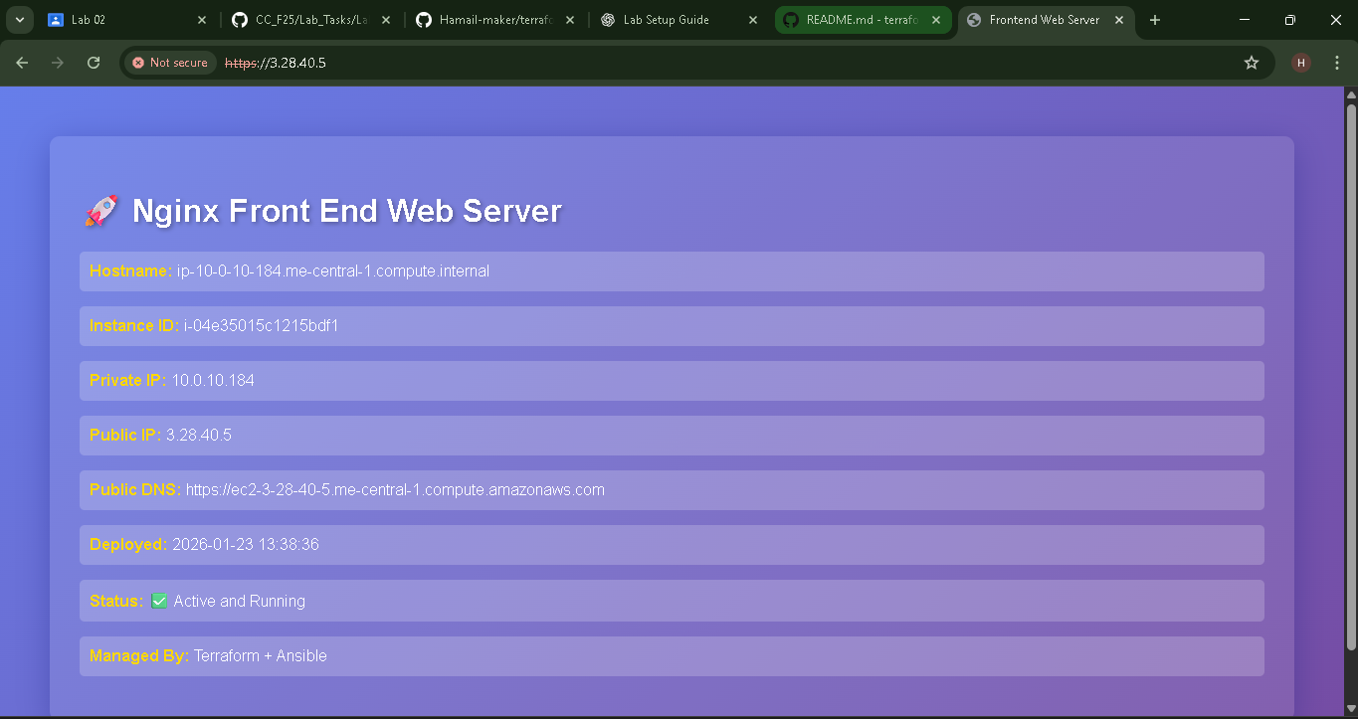

Task 8 – Docker & Docker Compose provisioning via Ansible
Deploy Docker and Docker Compose on a new EC2 instance.
- Destroy old infrastructure:
terraform destroy -auto-approve
- Save screenshot as: task8_terraform_destroy_old.png — destroy output for old stack.

- Recreate fresh infrastructure (1 instance):
terraform apply -auto-approve
terraform output
- Save screenshot as: task8_terraform_apply_docker_instance.png — new apply.

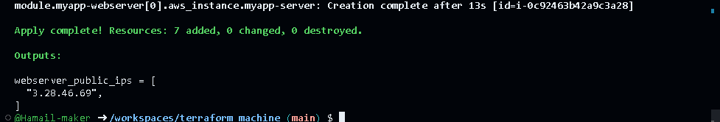

- Save screenshot as: task8_terraform_output_new_ip.png — output showing new instance IP.



- Update hosts:
[docker_servers]
<public-ip-new-ec2>

[docker_servers:vars]
ansible_ssh_private_key_file=~/.ssh/id_ed25519
ansible_user=ec2-user
- Save screenshot as: task8_hosts_docker_servers.png — hosts file showing [docker_servers].

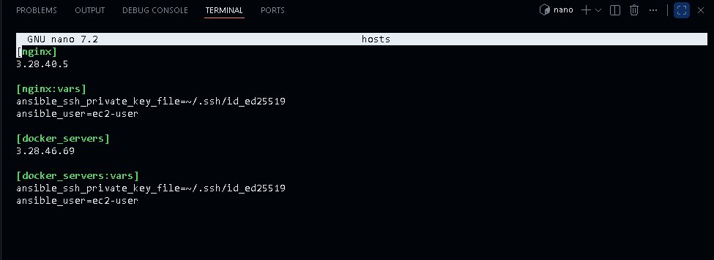

- Replace my-playbook.yaml content with:
---
- name: Configure Docker
hosts: all
become: true
tasks:
- name: install docker and update cache
yum:
name: docker
state: present
update_cache: yes

- name: Install Docker Compose
hosts: all
become: true
gather_facts: true
tasks:
- name: create docker cli-plugins directory
file:
path: /usr/local/lib/docker/cli-plugins
state: directory
mode: '0755'

- name: install docker-compose
get_url:
url: https://github.com/docker/compose/releases/latest/download/docker-compose-linux-{{ lookup('pipe', 'uname -m') }}
dest: /usr/local/lib/docker/cli-plugins/docker-compose
mode: +x

- name: View architecture of the system
debug:
msg: "System architecture of {{ inventory_hostname }} is {{ ansible_facts['architecture'] }}"

- name: Alternate method to view architecture of the system
debug:
msg: "System architecture of {{inventory_hostname}} is {{ lookup('pipe', 'uname -m') }}"

- name: restart docker service
service:
name: docker
state: restarted
- Save screenshot as: task8_my_playbook_docker.png — new Docker playbook content.

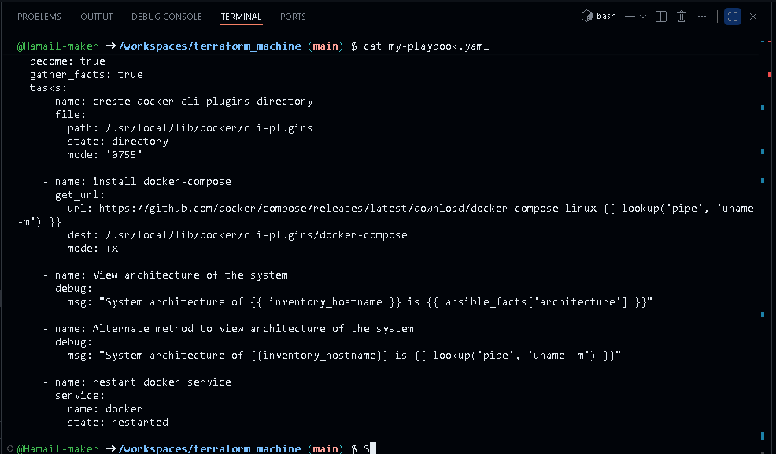

- Run the play:
ansible-playbook -i hosts my-playbook.yaml
- Save screenshot as: task8_ansible_play_docker.png — playbook output installing Docker and Compose.

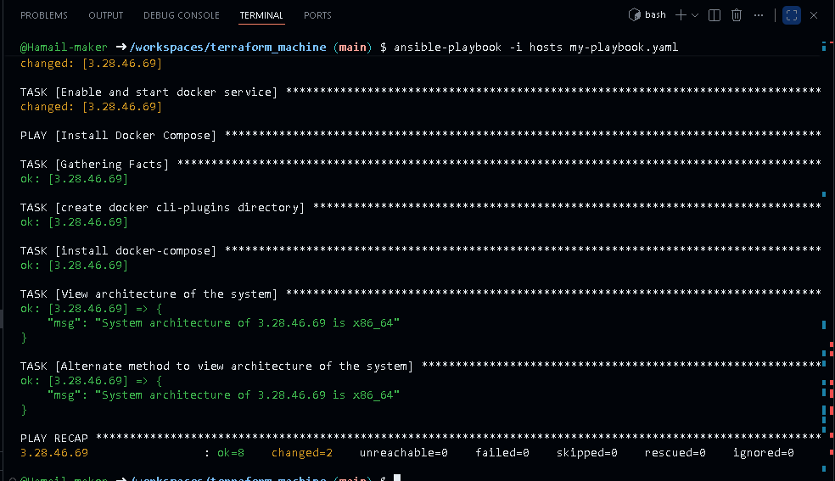

- Verify Docker:
ssh ec2-user@<public-ip> -i ~/.ssh/id_ed25519
sudo docker ps
exit
- Save screenshot as: task8_docker_ps_remote.png — sudo docker ps output from EC2 instance.

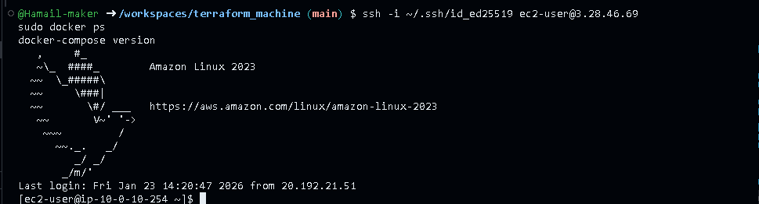

Task 9 – Gitea Docker stack via Ansible + Terraform security group update
Run containers for Gitea + Postgres and open port 3000 in the security group.
- Extend my-playbook.yaml by appending:
- name: Adding user to docker group
hosts: all
become: true
vars_files:
- project-vars.yaml
tasks:
- name: add user to docker group
user:
name: "{{ normal_user }}"
groups: docker
append: yes

- name: reconnect to apply group changes
meta: reset_connection

- name: verify docker access
command: docker ps
register: docker_ps
changed_when: false

- name: display docker ps output
debug:
var: docker_ps.stdout

- name: fail if docker is not accessible
fail:
msg: "Docker is not accessible on this host"
when: docker_ps.rc != 0
- Save screenshot as: task9_my_playbook_add_user_to_docker.png — new play appended in my-playbook.yaml.

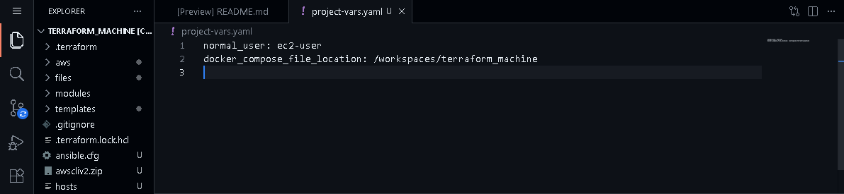

- Create project-vars.yaml:
touch project-vars.yaml
Add:
normal_user: ec2-user
docker_compose_file_location: <location-of-file>
- Save screenshot as: task9_project_vars.png — content of project-vars.yaml.

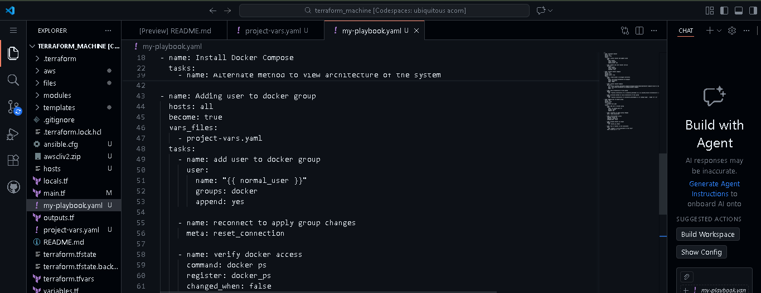

- Add the deploy containers play:
- name: Deploy Docker Containers
hosts: all
become: true
user: "{{ normal_user }}"
vars_files:
- project-vars.yaml
tasks:
- name: check if docker-compose file exists
stat:
path: /home/{{ normal_user }}/compose.yaml
register: compose_file

- name: copy docker-compose file
copy:
src: "{{ docker_compose_file_location }}/compose.yaml"
dest: /home/{{ normal_user }}/compose.yaml
mode: '0644'
when: not compose_file.stat.exists

- name: deploy containers using docker-compose
command: docker compose up -d
register: compose_result
changed_when: "'Creating' in compose_result.stdout or 'Recreating' in compose_result.stdout"
- Save screenshot as: task9_my_playbook_deploy_containers.png — final my-playbook.yaml with Docker deploy play.

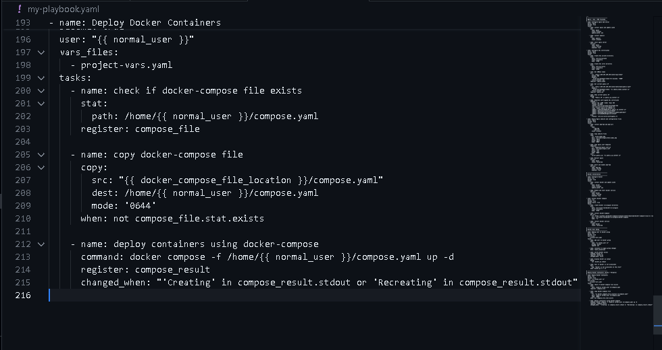

- Create compose.yaml in repo root:
touch compose.yaml
Fill with the Gitea + Postgres stack from instructions in compose.yaml.
services:
gitea:
image: gitea/gitea:latest
container_name: gitea
environment:
- DB_TYPE=postgres
- DB_HOST=db:5432
- DB_NAME=gitea
- DB_USER=gitea
- DB_PASSWD=gitea
restart: always
volumes:
- gitea:/data
ports:
- 3000:3000
extra_hosts:
- "www.jenkins.com:host-gateway"
networks:
- webnet
db:
image: postgres:alpine
container_name: gitea_db
environment:
- POSTGRES_USER=gitea
- POSTGRES_PASSWORD=gitea
- POSTGRES_DB=gitea
restart: always
volumes:
- gitea_postgres:/var/lib/postgresql/data
expose:
- 5432
networks:
- webnet

volumes:
gitea_postgres:
name: gitea_postgres
gitea:
name: gitea

networks:
webnet:
name: webnet
- Save screenshot as: task9_compose_yaml.png — content of compose.yaml.

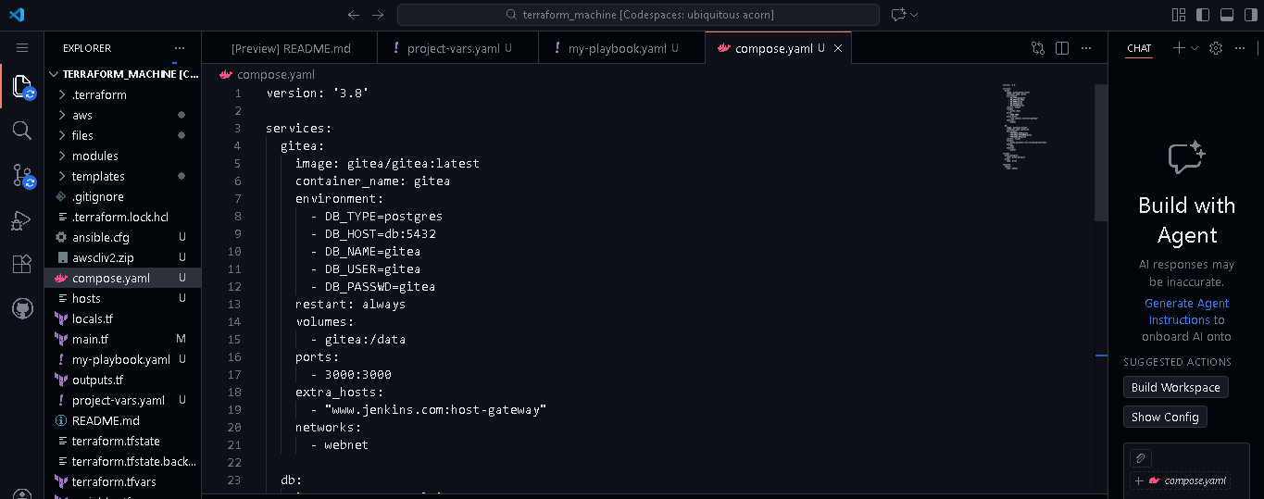

- Run playbook and visit the public-ip on your browser but webpage will not be shown due to permission issue:
ansible-playbook -i hosts my-playbook.yaml
- Save screenshot as: task9_ansible_play_gitea.png — playbook output showing Gitea/db containers created.

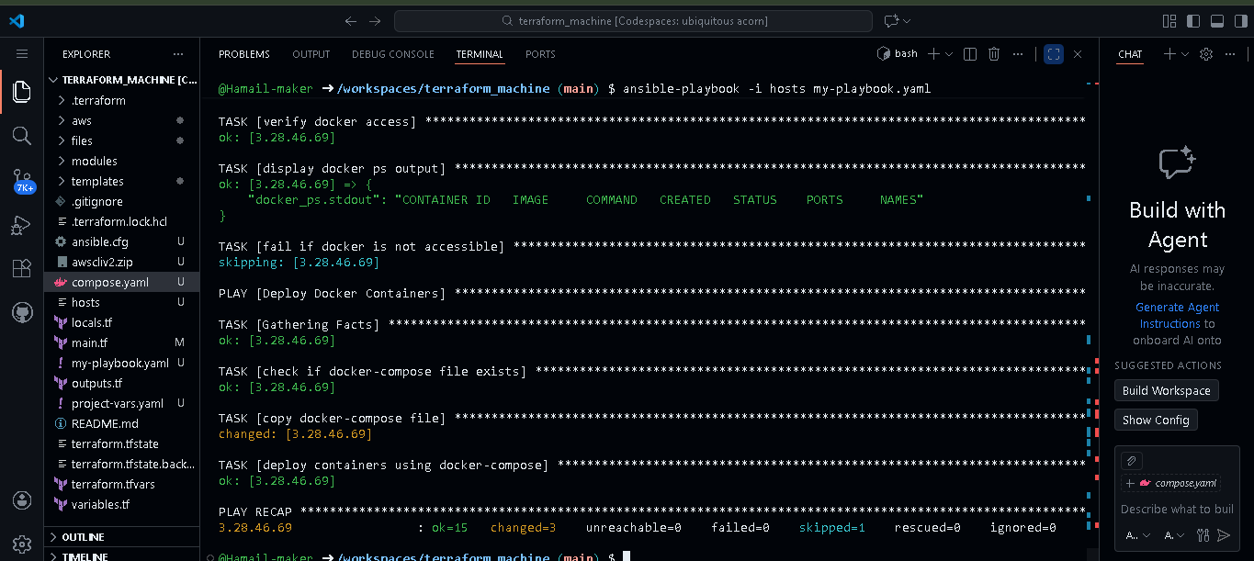

- Update security group in modules/webserver/main.tf to add port 3000:
ingress {
from_port = 3000
to_port = 3000
protocol = "tcp"
cidr_blocks = ["0.0.0.0/0"]
}
- Save screenshot as: task9_sg_ingress_3000.png — web_sg snippet showing 3000/tcp ingress.

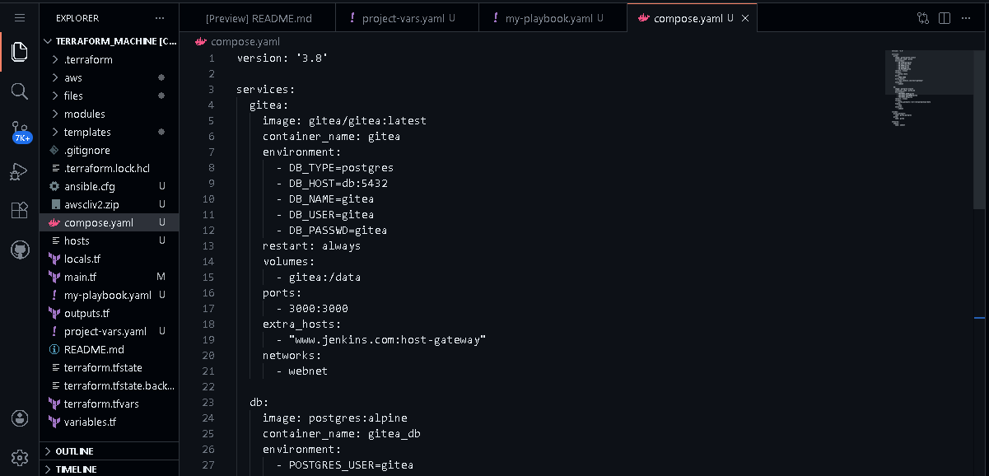

- Apply:
terraform apply -auto-approve

- Save screenshot as: task9_terraform_apply_sg_3000.png — apply output updating SG.

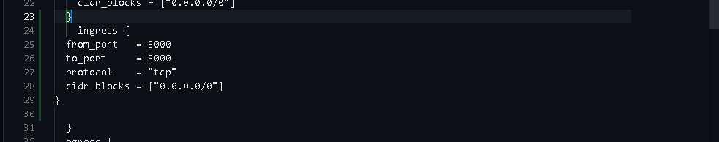

- Access Gitea:
Visit http://<public-ip>:3000.
- Save screenshot as: task9_gitea_browser.png — browser showing Gitea UI.

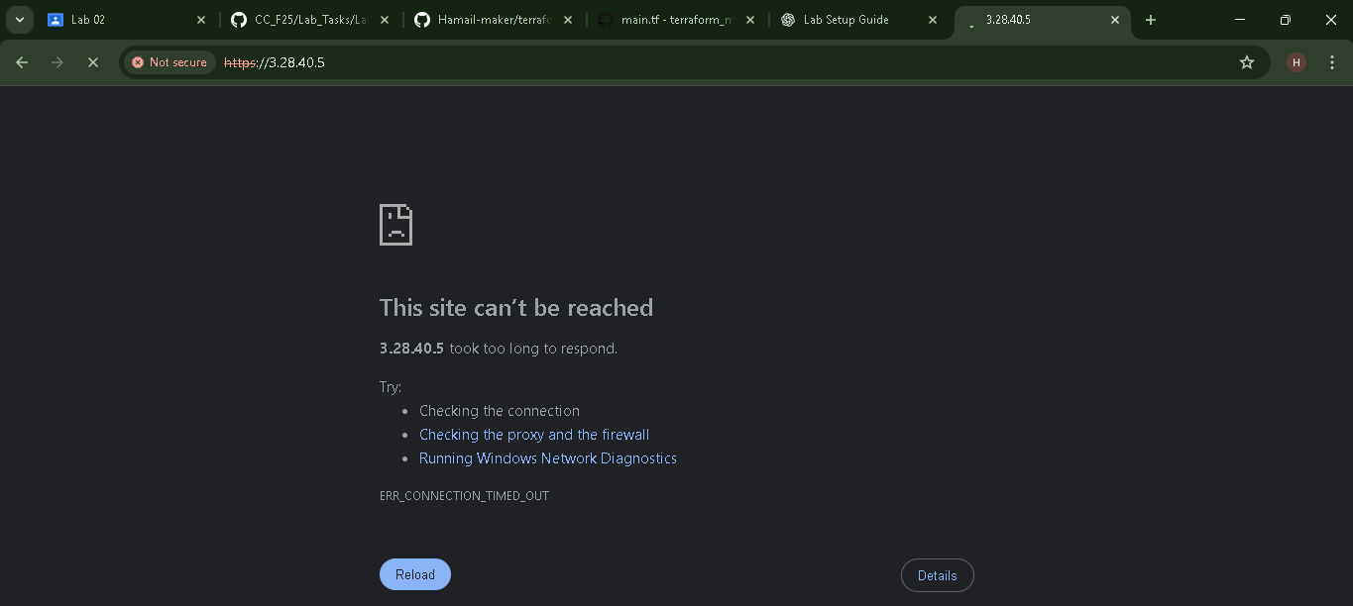

resource "null_resource" "configure_server" {
triggers = {
webserver_public_ips_for_ansible = join(",", [for i in module.myapp-webserver : i.aws_instance.public_ip])
}

depends_on = [module.myapp-webserver]

provisioner "local-exec" {
command = <<-EOT
ansible-playbook -i ${self.triggers.webserver_public_ips_for_ansible}, \
--private-key "${var.private_key}" --user ec2-user \
my-playbook.yaml
EOT
}
}

Task 10 – Automating Ansible with Terraform (null_resource)
Have Terraform trigger Ansible automatically after EC2 creation.
- Add null_resource to main.tf:
resource "null_resource" "configure_server" {
triggers = {
webserver_public_ips_for_ansible = join(",", [for i in module.myapp-webserver : i.aws_instance.public_ip])
}

depends_on = [module.myapp-webserver]

provisioner "local-exec" {
command = <<-EOT
ansible-playbook -i ${self.triggers.webserver_public_ips_for_ansible}, \
--private-key "${var.private_key}" --user ec2-user \
my-playbook.yaml
EOT
}
}
- Save screenshot as: task10_null_resource_main_tf.png — main.tf showing null_resource block.

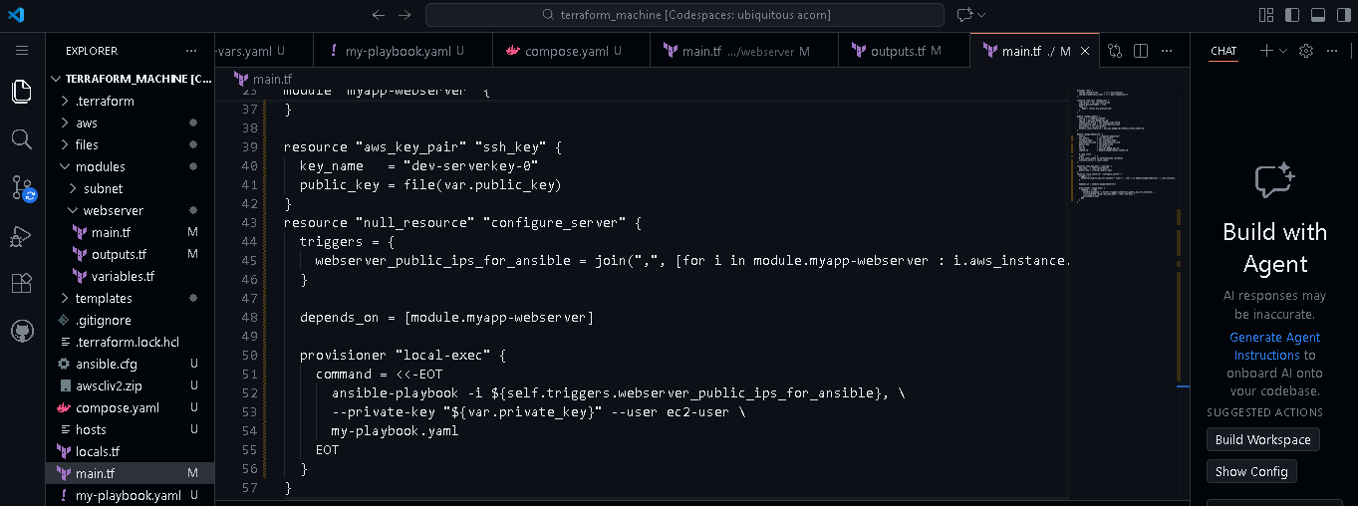

- Destroy and recreate infrastructure:
terraform destroy -auto-approve
terraform apply -auto-approve
- Save screenshot as: task10_terraform_destroy_before_null.png — destroy output.

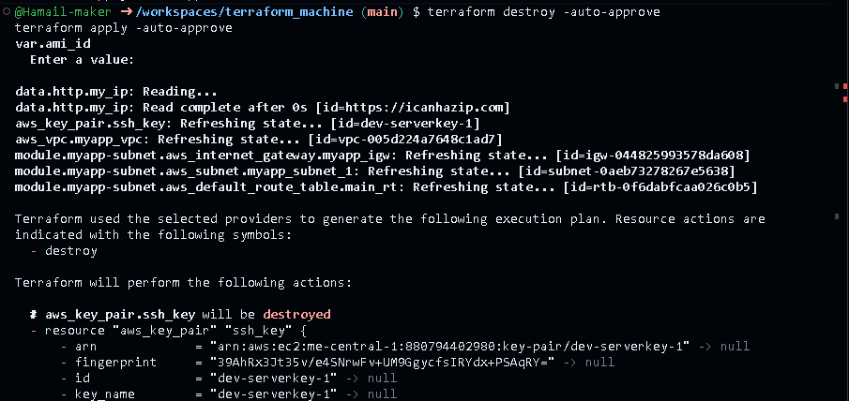

- Save screenshot as: task10_terraform_apply_with_local_exec.png — apply output showing local-exec / Ansible execution.

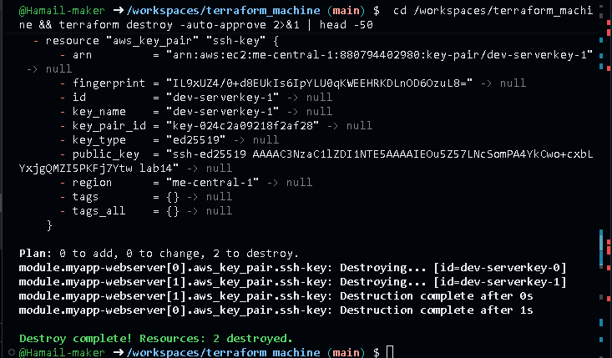

- If Ansible fails due to readiness, add a wait play at the top of my-playbook.yaml:
- name: Wait for some time to ensure system readiness
hosts: all
tasks:
- name: Wait 300 seconds for port 22 to become open and contain "OpenSSH"
wait_for:
port: 22
host: "{{ inventory_hostname }}"
delay: 10
timeout: 300
delegate_to: localhost
- Save screenshot as: task10_my_playbook_wait_for_ssh.png — top wait play in file.

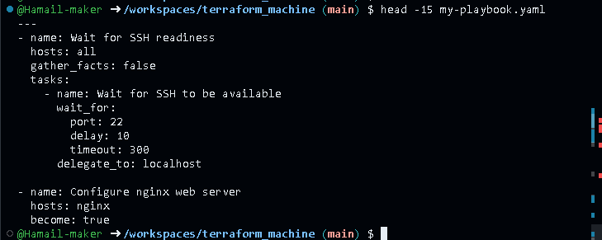

- Destroy and apply again:
terraform destroy -auto-approve
terraform apply -auto-approve
- Save screenshot as: task10_terraform_apply_after_wait.png — apply output after wait fix.

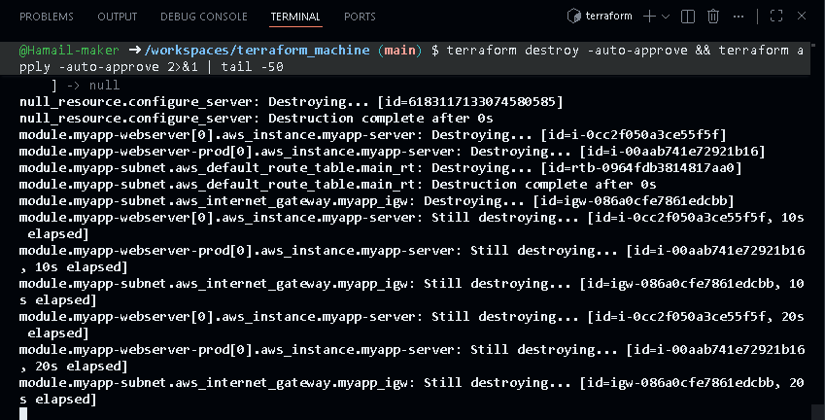
- Verify Gitea / Nginx application is reachable at the appropriate URL.
  - Save screenshot as: task10_app_browser_post_null_resource.png — browser confirming app is up after Terraform+Ansible.
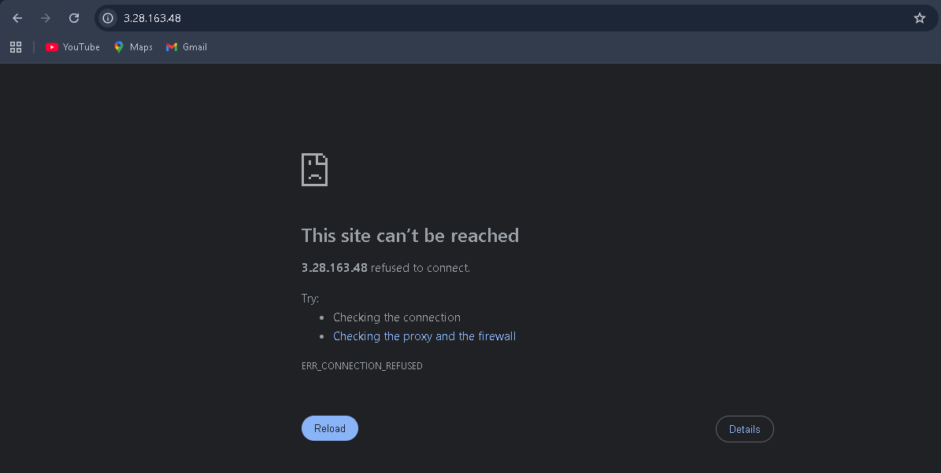

Task 11: Dynamic inventory with aws_ec2 plugin
Step 1: Show updated ansible.cfg with aws_ec2 plugin:

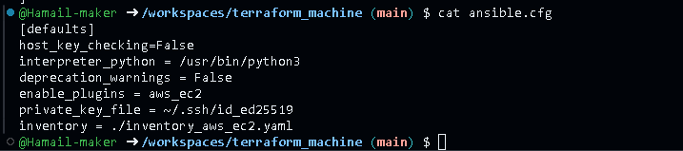

Step 2: Verify inventory_aws_ec2.yaml exists:

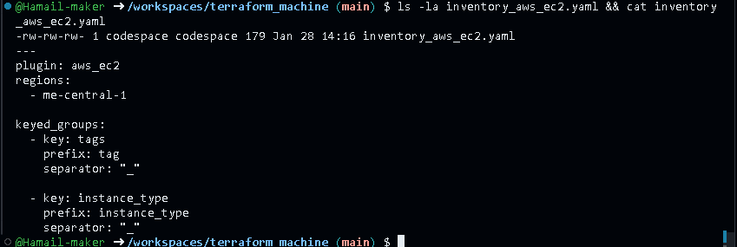

Step 3: Show main.tf with both dev and prod webserver modules:

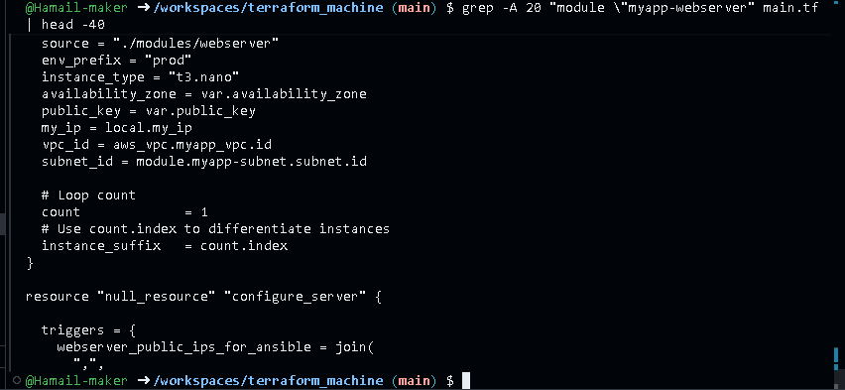

Step 4: Show outputs.tf with both outputs:

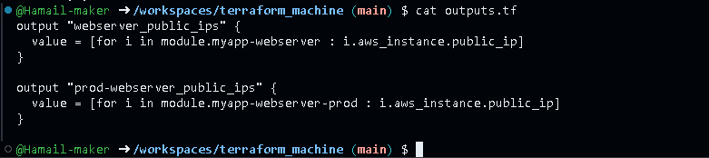

Step 5: Rebuild infrastructure:

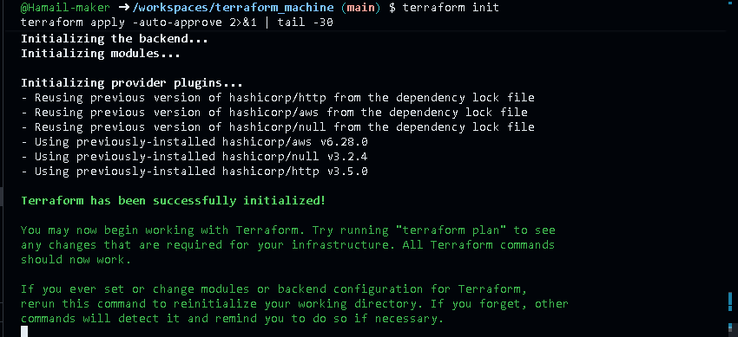

Step 6: Show Terraform outputs:

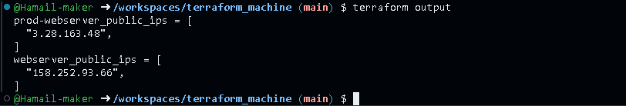

Step 7: Install boto3 and botocore:

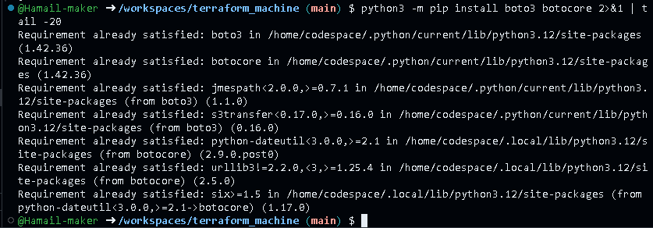

Step 8: Verify boto3 version:

Step 9: Check inventory graph:

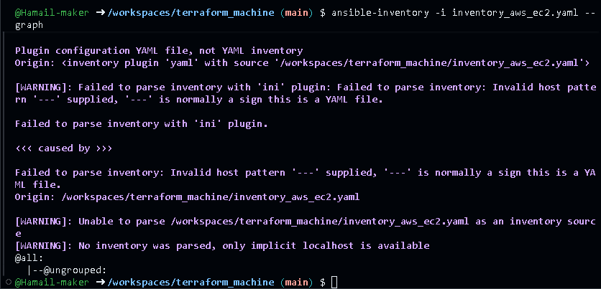

Task 12: Filtering EC2 instances by tags & instance type
Step 1: Update inventory_aws_ec2.yaml with tag grouping:

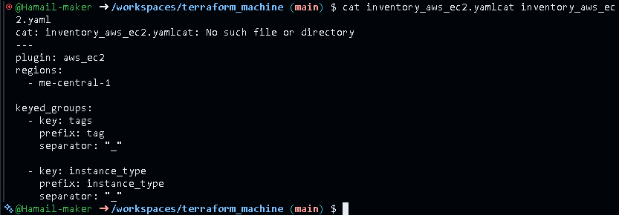

Step 2: Check graph with tag groups:

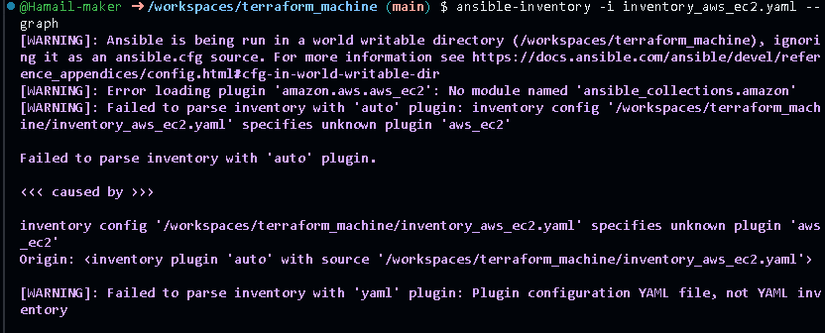

Step 3: Extend inventory_aws_ec2.yaml to include instance_type grouping (already done):

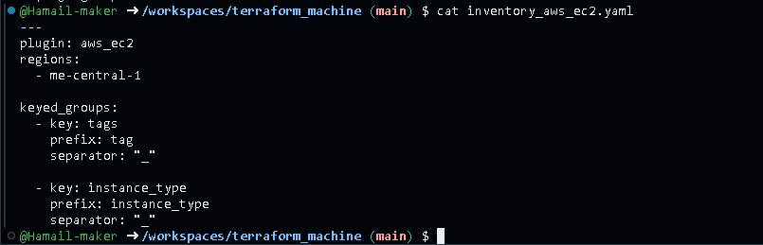

Step 4: Check updated graph:

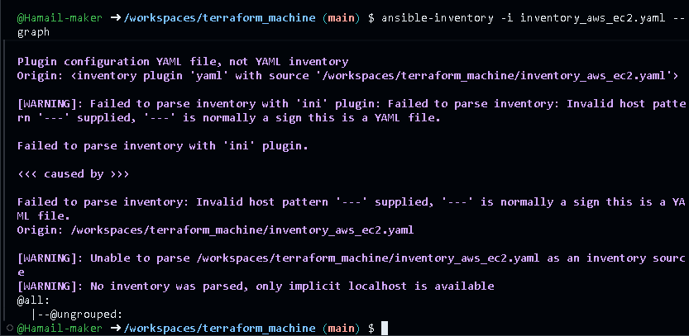

Step 5: Show playbook with hosts: all:

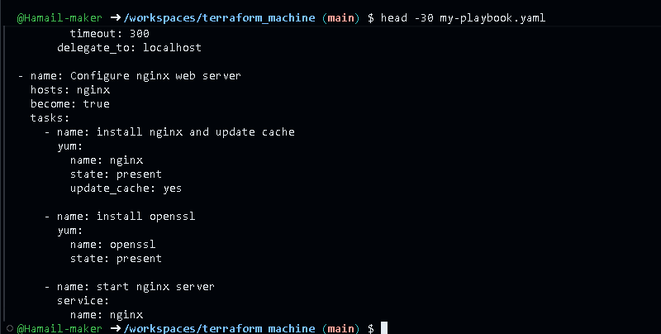

Step 6: Run playbook on all hosts:

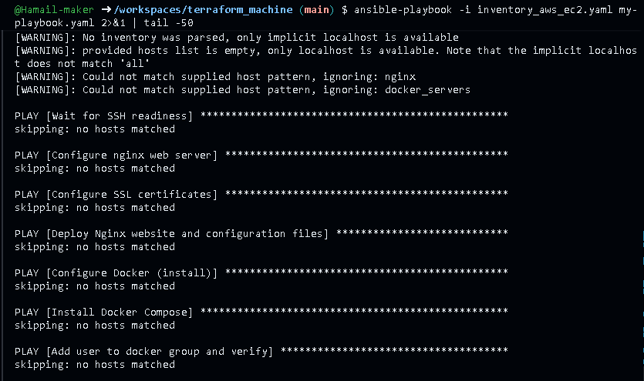

Step 7: Run on dev instances only:

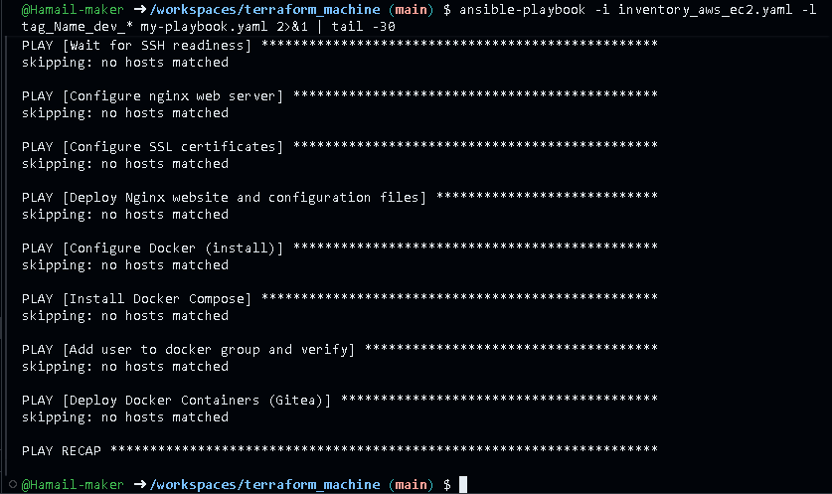

Step 8: Run on prod instances only:

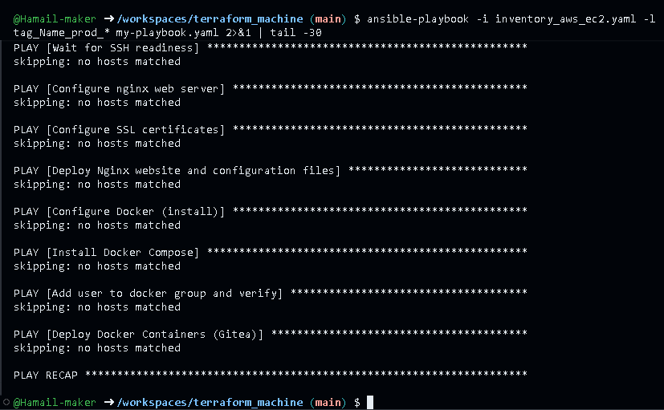

Step 9: Run on t3.micro instances:

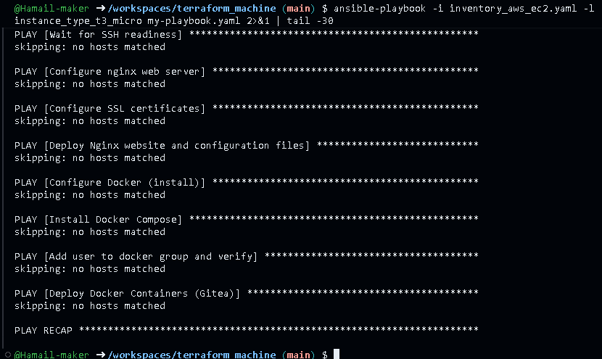

Step 10: Run on t3.nano instances:

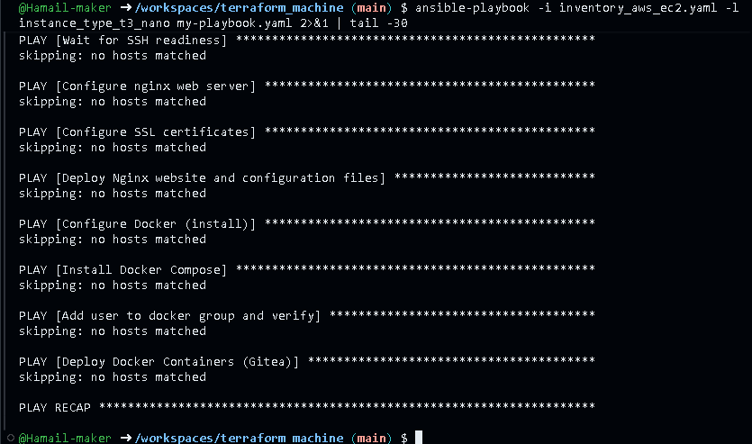

Step 11: Show ansible.cfg with default inventory set:

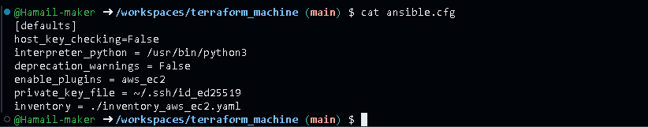

Step 12: Run playbook without -i flag (uses default inventory):

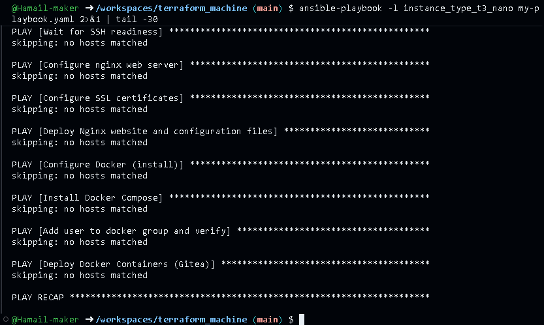

Task 13 – Ansible roles: nginx, ssl, webapp
Reorganize your configuration into roles.
- Update main.tf for a simple dev environment with 1 instance (as shown previously).
provider "aws" {
shared_config_files = ["~/.aws/config"]
shared_credentials_files = ["~/.aws/credentials"]
}

resource "aws_vpc" "myapp_vpc" {
cidr_block = var.vpc_cidr_block
enable_dns_hostnames = true
tags = {
Name = "${var.env_prefix}-vpc"
}
}

module "myapp-subnet" {
source = "./modules/subnet"
vpc_id = aws_vpc.myapp_vpc.id
subnet_cidr_block = var.subnet_cidr_block
availability_zone = var.availability_zone
env_prefix = var.env_prefix
default_route_table_id = aws_vpc.myapp_vpc.default_route_table_id
}

module "myapp-webserver" {
source = "./modules/webserver"
env_prefix = var.env_prefix
instance_type = var. instance_type
availability_zone = var.availability_zone
public_key = var.public_key
my_ip = local.my_ip
vpc_id = aws_vpc.myapp_vpc.id
subnet_id = module.myapp-subnet.subnet.id

# Loop count
count = 1
# Use count.index to differentiate instances
instance_suffix = count.index
}
- Save screenshot as: task13_main_tf_single_dev.png — main.tf snippet with single myapp-webserver count=1.

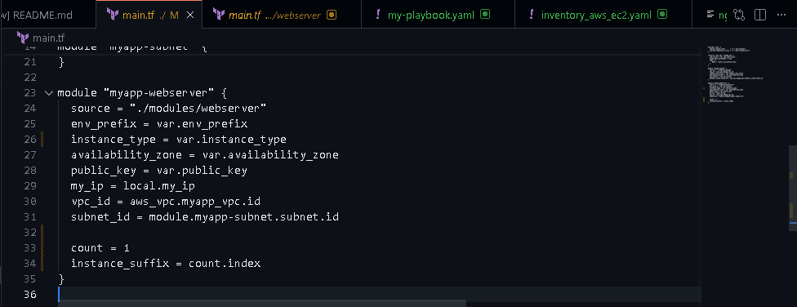

- Create /ansible structure:
mkdir -p ansible
cd ansible
mkdir inventory roles
touch ansible.cfg my-playbook.yaml
ls -R
- Save screenshot as: task13_ansible_structure_created.png — ls -R showing ansible/, inventory/, roles/, ansible.cfg, my-playbook.yaml.

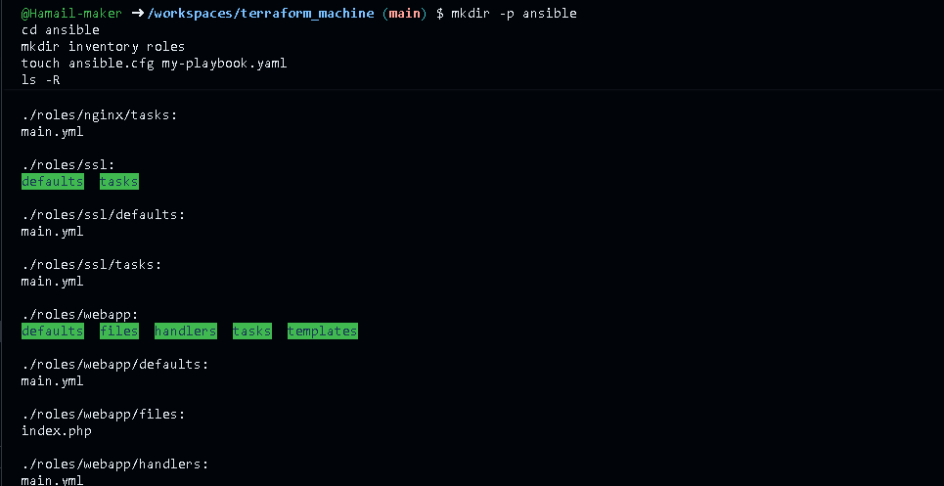

- ansible/ansible.cfg:
[defaults]
host_key_checking=False
interpreter_python = /usr/bin/python3
- Save screenshot as: task13_ansible_cfg_project.png — content of ansible/ansible.cfg.

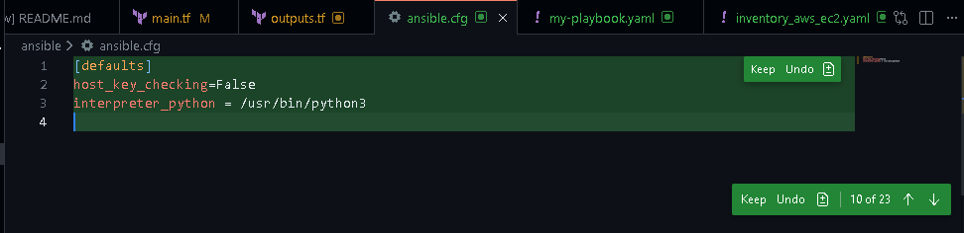

- ansible/inventory/hosts:
[nginx]
<public-ip-of-machine>

[nginx:vars]
ansible_ssh_private_key_file=~/.ssh/id_ed25519
ansible_user=ec2-user
- Save screenshot as: task13_ansible_inventory_hosts.png — content of ansible/inventory/hosts.

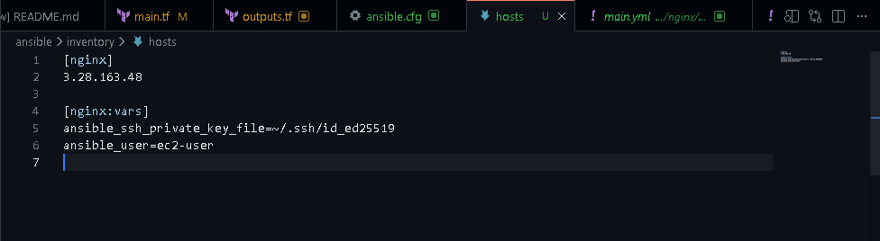

- Create roles:
cd roles
ansible-galaxy role init nginx
ansible-galaxy role init ssl
ansible-galaxy role init webapp
cd ..
ls -R
- Save screenshot as: task13_roles_created.png — ls -R under ansible/roles showing nginx, ssl, webapp.

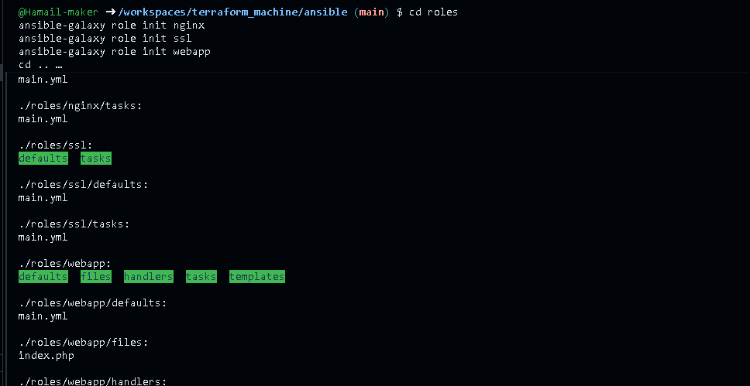

- Role: nginx
- ansible/roles/nginx/handlers/main.yml:
- name: Restart nginx
service:
name: nginx
state: restarted
- Save screenshot as: task13_nginx_handlers_main.png — content of roles/nginx/handlers/main.yml.
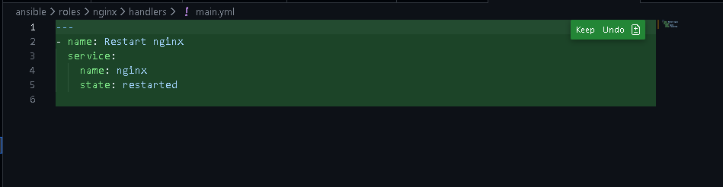

- ansible/roles/nginx/tasks/main.yml:
- name: Install nginx
yum:
name: nginx
state: present
update_cache: yes
notify: Restart nginx

- name: Install openssl
yum:
name: openssl
state: present

- name: Start and enable nginx
service:
name: nginx
state: started
enabled: true
- Save screenshot as: task13_nginx_tasks_main.png — content of roles/nginx/tasks/main.yml.

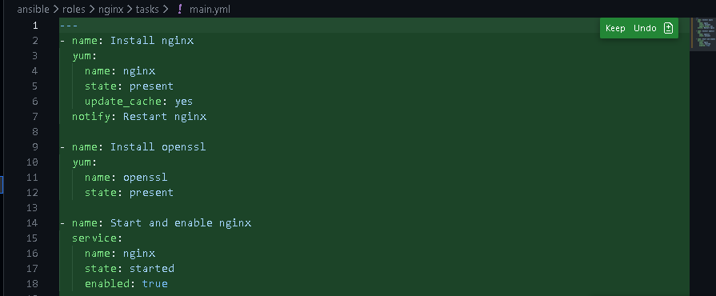

- First role-based playbook ansible/my-playbook.yaml:
---
- name: Deploy NGINX Web Stack with SSL and PHP
hosts: nginx
become: true
roles:
- nginx
- Save screenshot as: task13_my_playbook_nginx_only.png — playbook using only nginx role.

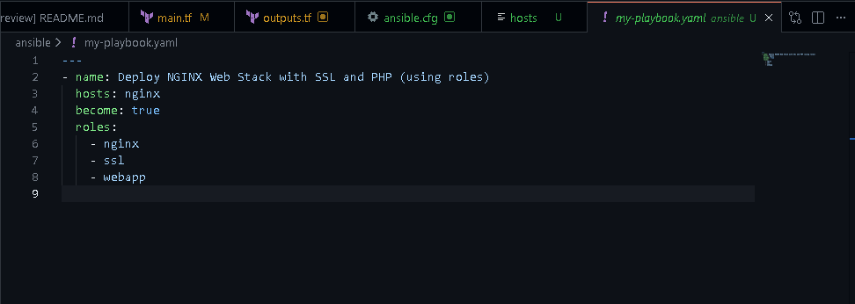

Run:
chmod 755 $(pwd)
ansible-playbook -i inventory/hosts my-playbook.yaml
- Save screenshot as: task13_ansible_play_nginx_only.png — playbook output.

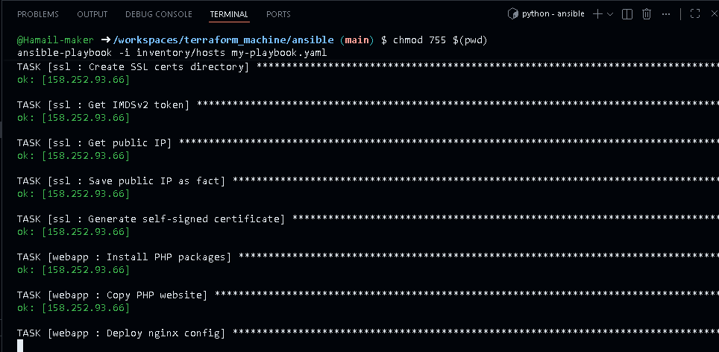

- Save screenshot as: task13_nginx_browser_roles.png — browser showing nginx default page via roles.

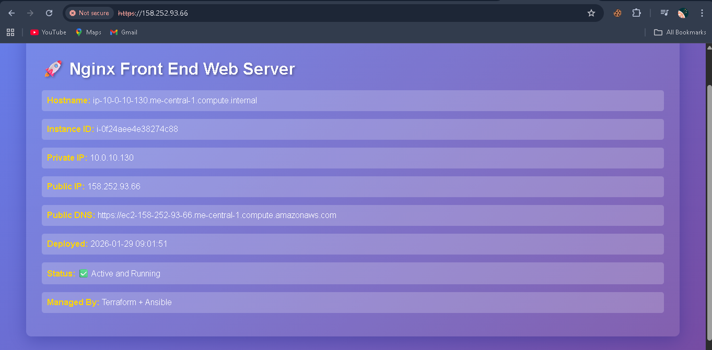

- Role: ssl
- ansible/roles/ssl/defaults/main.yml:
imdsv2_token_ttl: "3600"
ssl_days_valid: 365
- Save screenshot as: task13_ssl_defaults_main.png — content of roles/ssl/defaults/main.yml.

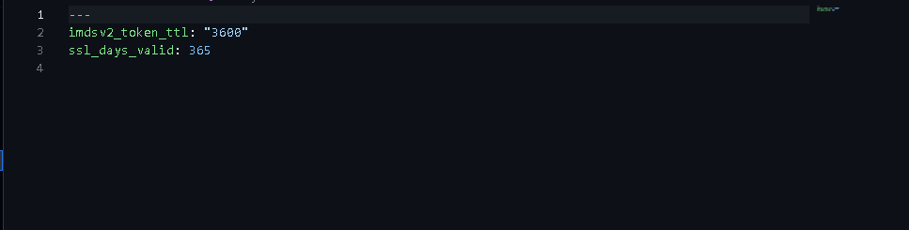

- ansible/roles/ssl/tasks/main.yml:
- name: Create SSL private directory
file:
path: /etc/ssl/private
state: directory
mode: '0700'

- name: Create SSL certs directory
file:
path: /etc/ssl/certs
state: directory
mode: '0755'

- name: Get IMDSv2 token
uri:
url: http://169.254.169.254/latest/api/token
method: PUT
headers:
X-aws-ec2-metadata-token-ttl-seconds: "{{ imdsv2_token_ttl }}"
return_content: yes
register: imds_token

- name: Get public IP
uri:
url: http://169.254.169.254/latest/meta-data/public-ipv4
headers:
X-aws-ec2-metadata-token: "{{ imds_token.content }}"
return_content: yes
register: public_ip

- name: Save public IP as fact
set_fact:
server_public_ip: "{{ public_ip.content }}"

- name: Generate self-signed certificate
command: >
openssl req -x509 -nodes -days {{ ssl_days_valid }}
-newkey rsa:2048
-keyout /etc/ssl/private/selfsigned.key
-out /etc/ssl/certs/selfsigned.crt
-subj "/CN={{ server_public_ip }}"
-addext "subjectAltName=IP:{{ server_public_ip }}"
args:
creates: /etc/ssl/certs/selfsigned.crt
- Save screenshot as: task13_ssl_tasks_main.png — content of roles/ssl/tasks/main.yml.

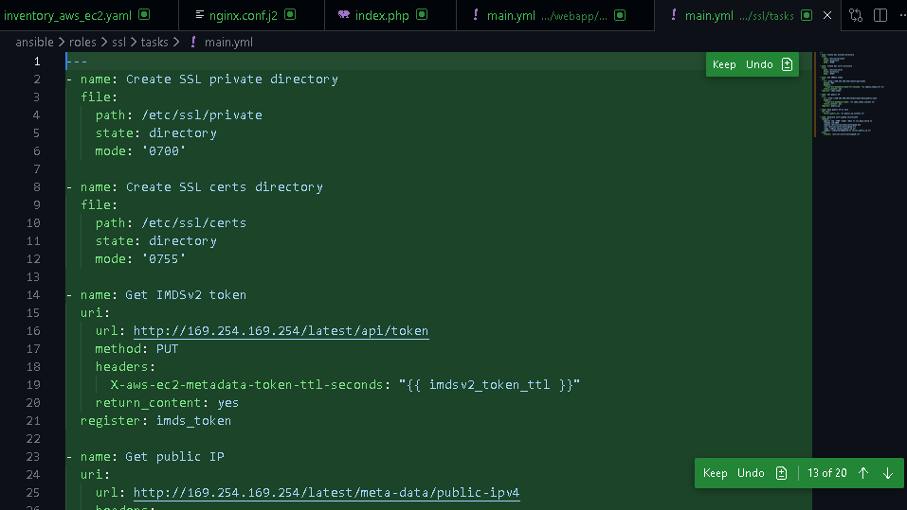

- Role: webapp
- ansible/roles/webapp/defaults/main.yml:
nginx_user: nginx
nginx_worker_processes: auto
nginx_worker_connections: 1024
nginx_error_log_level: notice

# Webapp settings
web_root: /usr/share/nginx/html
web_index_file: index.php
- Save screenshot as: task13_webapp_defaults_main.png — content of roles/webapp/defaults/main.yml.

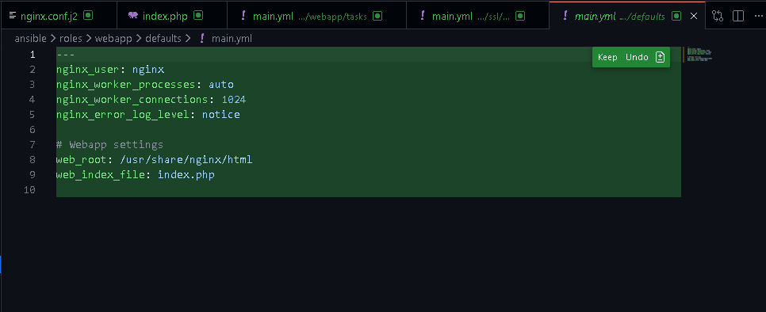

- ansible/roles/webapp/files/index.php – PHP metadata page.
<?php
// Get hostname
$hostname = gethostname();

// Deployment date
$deployed_date = date("Y-m-d H:i:s");

// Metadata base URL
$metadata_base = "http://169.254.169.254/latest/";

// Function to get IMDSv2 token
function getImdsV2Token() {
$ch = curl_init("http://169.254.169.254/latest/api/token");
curl_setopt_array($ch, [
CURLOPT_RETURNTRANSFER => true,
CURLOPT_CUSTOMREQUEST => "PUT",
CURLOPT_HTTPHEADER => [
"X-aws-ec2-metadata-token-ttl-seconds: 21600"
],
CURLOPT_TIMEOUT => 2
]);

$token = curl_exec($ch);
curl_close($ch);

return $token ?: null;
}

// Function to fetch metadata using token
function getMetadata($path, $token) {
$url = "http://169.254.169.254/latest/meta-data/" . $path;

$ch = curl_init($url);
curl_setopt_array($ch, [
CURLOPT_RETURNTRANSFER => true,
CURLOPT_HTTPHEADER => [
"X-aws-ec2-metadata-token: $token"
],
CURLOPT_TIMEOUT => 2
]);

$value = curl_exec($ch);
curl_close($ch);

return $value ?: "N/A";
}

// Fetch token
$token = getImdsV2Token();

// Fetch metadata only if token is available
$instance_id = $token ? getMetadata("instance-id", $token) : "N/A";
$private_ip = $token ? getMetadata("local-ipv4", $token) : "N/A";
$public_ip = $token ? getMetadata("public-ipv4", $token) : "N/A";
$public_dns = $token ? getMetadata("public-hostname", $token) : "N/A";
?>
<!DOCTYPE html>
<html>
<head>
<title>Frontend Web Server</title>
<style>
body {
font-family: Arial, sans-serif;
margin: 50px;
background: linear-gradient(135deg, #667eea 0%, #764ba2 100%);
color: white;
}
.container {
background: rgba(255, 255, 255, 0.1);
padding: 30px;
border-radius: 10px;
box-shadow: 0 8px 32px rgba(31, 38, 135, 0.37);
}
h1 {
color: #fff;
text-shadow: 2px 2px 4px rgba(0,0,0,0.3);
}
.info {
margin: 15px 0;
padding: 10px;
background: rgba(255,255,255,0.2);
border-radius: 5px;
}
.label {
font-weight: bold;
color: #ffd700;
}
.info a {
color: white; /* same as other values */
text-decoration: none; /* remove underline */
font-weight: normal;
}

.info a:hover {
text-decoration: underline; /* optional: underline on hover */
}
</style>
</head>
<body>
<div class="container">
<h1>🚀 Nginx Front End Web Server </h1>

<div class="info"><span class="label">Hostname:</span> <?= htmlspecialchars($hostname) ?></div>
<div class="info"><span class="label">Instance ID:</span> <?= htmlspecialchars($instance_id) ?></div>
<div class="info"><span class="label">Private IP:</span> <?= htmlspecialchars($private_ip) ?></div>
<div class="info"><span class="label">Public IP:</span> <?= htmlspecialchars($public_ip) ?></div>
<div class="info"><span class="label">Public DNS:</span>
<a href="https://<?= htmlspecialchars($public_dns) ?>" target="_blank">
https://<?= htmlspecialchars($public_dns) ?></a>
</div>
<div class="info"><span class="label">Deployed:</span> <?= $deployed_date ?></div>
<div class="info"><span class="label">Status:</span> ✅ Active and Running</div>
<div class="info"><span class="label">Managed By:</span> Terraform + Ansible</div>
</div>
</body>
</html>
- Save screenshot as: task13_webapp_files_index_php.png — content of roles/webapp/files/index.php.

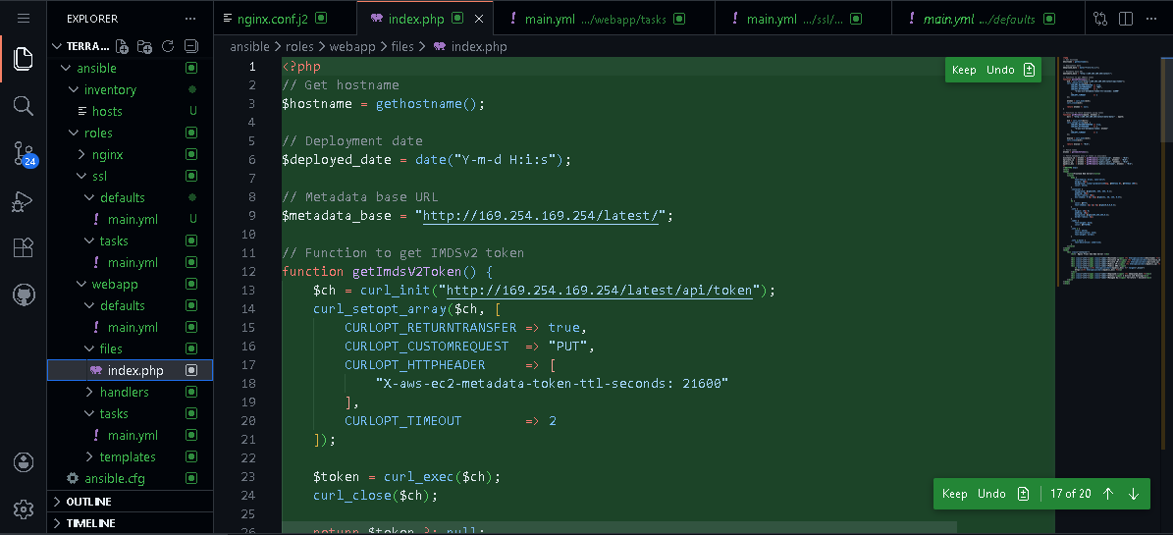

- ansible/roles/webapp/handlers/main.yml:
- name: Restart nginx
service:
name: nginx
state: restarted

- name: Restart php-fpm
service:
name: php-fpm
state: restarted
- Save screenshot as: task13_webapp_handlers_main.png — content of roles/webapp/handlers/main.yml.

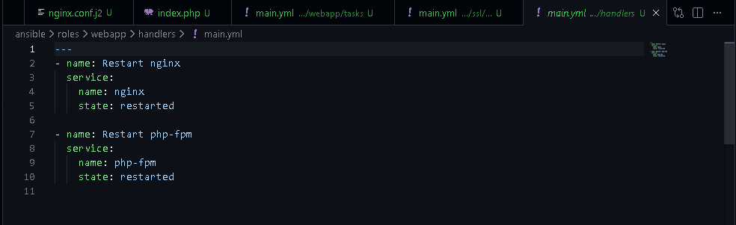

- ansible/roles/webapp/templates/nginx.conf.j2:
user {{ nginx_user }};
worker_processes {{ nginx_worker_processes }};
error_log /var/log/nginx/error.log {{ nginx_error_log_level }};
pid /run/nginx.pid;

events {
worker_connections {{ nginx_worker_connections }};
}

http {
log_format main '$remote_addr - $remote_user [$time_local] "$request"'
'$status $body_bytes_sent "$http_referer"'
'"$http_user_agent" "$http_x_forwarded_for"';

access_log /var/log/nginx/access.log main;

sendfile on;
tcp_nopush on;
keepalive_timeout 65;
types_hash_max_size 4096;

include /etc/nginx/mime.types;
default_type application/octet-stream;

upstream backend_servers {
server 158.252.94.241:80;
server 158.252.94.242:80 backup;
}

server {
listen 443 ssl;
server_name {{ server_public_ip }};

ssl_certificate /etc/ssl/certs/selfsigned.crt;
ssl_certificate_key /etc/ssl/private/selfsigned.key;

location / {
root {{ web_root }};
index {{ web_index_file }} index.html index.htm;
# proxy_pass http://158.252.94.241:80;
# proxy_pass http://backend_servers;

location / {
try_files $uri $uri/ =404;
}

# 🔴 This block is necessary for Php Website
location ~ \.php$ {
include fastcgi_params;
fastcgi_pass unix:/run/php-fpm/www.sock;
fastcgi_index index.php;
fastcgi_param SCRIPT_FILENAME $document_root$fastcgi_script_name;
}
}
}

server {
listen 80;
server_name _;
return 301 https://$host$request_uri;
}
}
- Save screenshot as: task13_webapp_templates_nginx_conf.png — content of roles/webapp/templates/nginx.conf.j2.

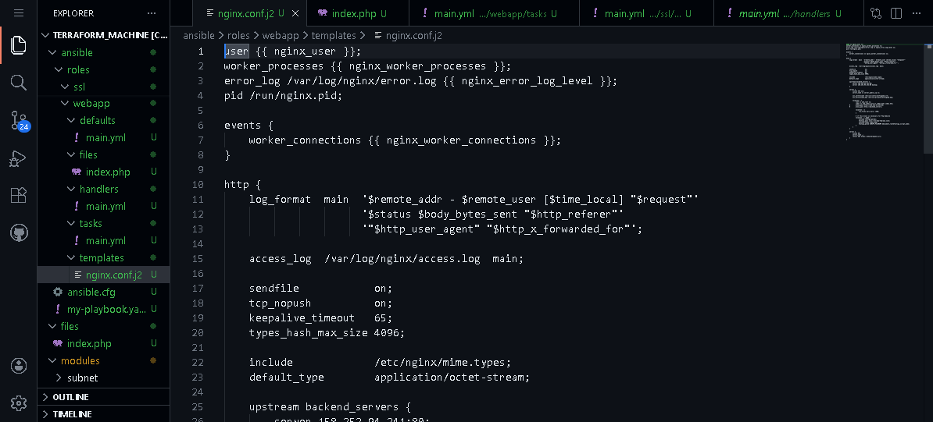

- ansible/roles/webapp/tasks/main.yml:
- name: Install PHP packages
yum:
name:
- php-fpm
- php-curl
state: present
notify: Restart php-fpm

- name: Copy PHP website
copy:
src: index.php
dest: "{{ web_root }}/{{ web_index_file }}"
owner: nginx
group: nginx
mode: '0644'
notify: Restart nginx

- name: Deploy nginx config
template:
src: nginx.conf.j2
dest: /etc/nginx/nginx.conf
notify: Restart nginx

- name: Start and enable php-fpm
service:
name: php-fpm
state: started
enabled: true
- Save screenshot as: task13_webapp_tasks_main.png — content of roles/webapp/tasks/main.yml.

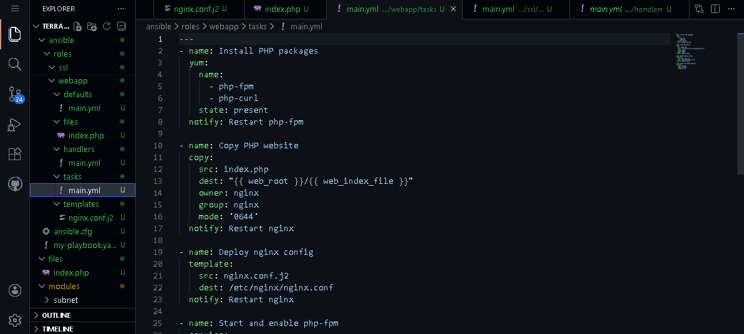

- Final role-based playbook ansible/my-playbook.yaml:
---
- name: Deploy NGINX Web Stack with SSL and PHP
hosts: nginx
become: true
roles:
- nginx
- ssl
- webapp
- Save screenshot as: task13_my_playbook_roles.png — final my-playbook.yaml referencing three roles.

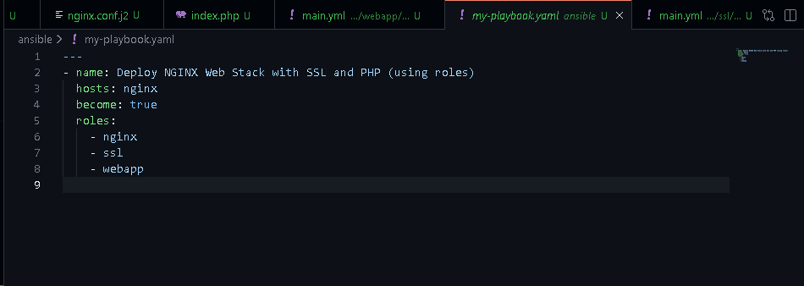

- Run:
ansible-playbook -i inventory/hosts my-playbook.yaml
- Save screenshot as: task13_ansible_play_roles.png — playbook output with all roles executed.

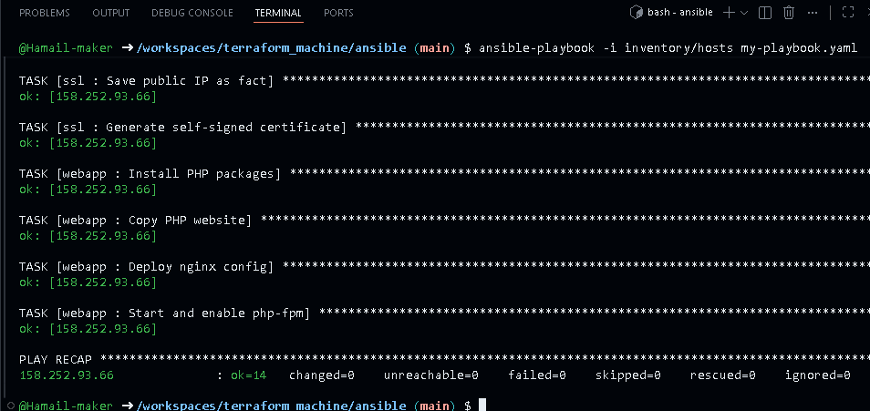

Visit https://<public-ip> and verify the PHP page with metadata.
- Save screenshot as: task13_php_https_browser_roles.png — browser showing final PHP page via HTTPS.

